**Lab 1: PHW 1**

**조현식, 이연희, 장준, 함민혁**

**# Index**

**1. Conclusion**

**2. Team member contribution**

**2. Source Code**

**3. Output Results**

**1. Conclusion**

First, we checked the null value for dataset. Based on the experience, “ID” is determined as a column that is not necessary in this data analysis. After checking the dataset, “Bare Nuclears” is numeric data, but the type is object type. Also we found that some of the value is '?'. To preserve as much data as possible, '?' were replaced with the mean value of the corresponding column.

Use Correlation to check the relationship between the target feature "class" and the rest of the features. We find that “Mitoses” is relatively less associated with “class” than other features. So, we decided to drop "Mitoses" column.

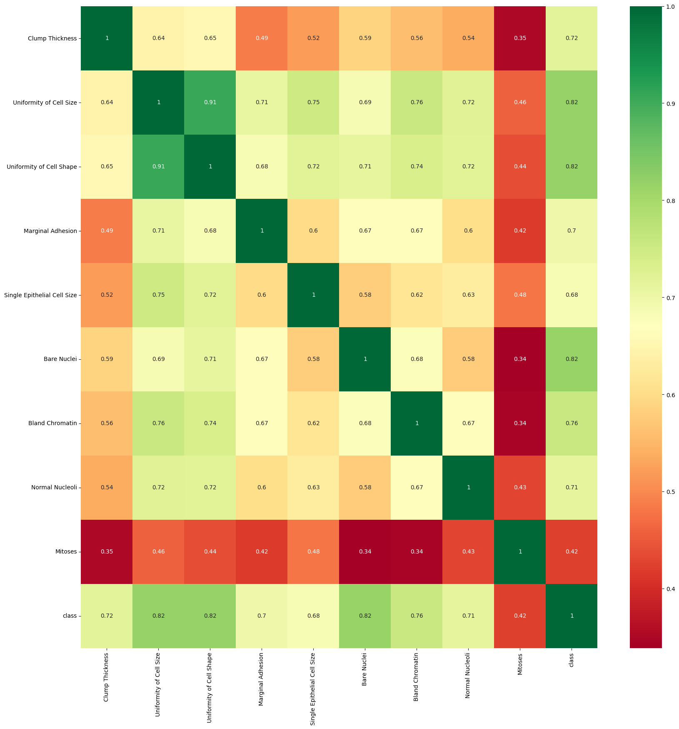

When we print out all the results, we can see that svm has the highest accuracy. The next ranking is the logistic regression model, and the third is the decision tree model. Also, in svm, the kernel in the form of sigmoid was mainly high in accuracy.

Since linear svm is limited to two dimensions, it can be confirmed that the accuracy appears high in other types of kernels. And the difference in score for the criterion of the decision tree was very small.

C is a parameter that determines how many data samples are allowed to be placed in another class, and it can be seen that the C value shows high accuracy when it is 0.1. However, it should be noted that there is a risk of underfitting if the C value is too small and overfitting if it is high.(also in gamma). Also, in the SVM model, the score showed a big difference according to gamma and C parameters. (97%~30%)

In the case of the scaler, the standard scaler had the highest average value on average and the minmax was the lowest. (However, since this is an average that does not take into account other columns, it cannot be said to be an exact number, but it is a number that is somewhat consistent when directly checking the upper, middle, and lower ranks in accuracy. ) Also the score difference according to the scaling method was very small.

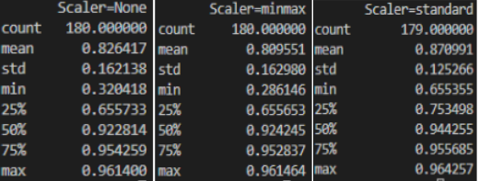

SVM is a powerful model and works well on a variety of datasets. However, it should not always be concluded that SVM is powerful.

When the amount of samples is large, it often does not fit well. After all, it is also up to the user to decide this.

**2. Team member contribution**

|  |  |  |  |  |
| --- | --- | --- | --- | --- |
| **Name** | 조현식 | 이연희 | 장준 | 함민혁 |
| **Contribution(%)** | 25% | 25% | 25% | 25% |

All team members wrote their own code from start to finish, had a meeting time to modify and integrate the code, and analyze it together.

**3. Source Code**

# Import libraries

import numpy as np

import pandas as pd

import seaborn as sns

import matplotlib.pyplot as plt

from sklearn import preprocessing

from sklearn.svm import SVC

from sklearn.metrics import accuracy_score

from sklearn.model_selection import train_test_split, cross_val_score, KFold

from sklearn.tree import DecisionTreeClassifier, plot_tree

from sklearn.linear_model import LogisticRegression

# score list (modelName, scalerName, parameters, score)

score_list = []

# =====================================================================

# Function Name : load_and_modification_dataset

# Function Description : Loads and modifies the dataset.

# Input :

# fileName = dataset fileName (including Path, if you need)

# Output : Show Data Exploration(original, modified), return Modified dataset

# =====================================================================

def load_and_modification_dataset(fileName):

# Load dataset

df = pd.read_csv(fileName)

# Data Exploration -----------------------------------

print('='*27, '<Original Dataset>', '='*27)

print(df.info(), end='\n\n')

display(df)

# Data Preprocessing ---------------------------------

# Drop ID columns

df = df.drop(['ID'], axis=1)

# Clean the dirty data in Bare Nuclei using mean

df['Bare Muclei'].value_counts()

df['Bare Muclei'] = df['Bare Muclei'].replace("?", "")

df['Bare Muclei'] = pd.to_numeric(df['Bare Muclei'])

df['Bare Muclei'] = df['Bare Muclei'].fillna(df['Bare Muclei'].mean())

# get correlations of pairs of features in the dataset

corrmat = df.corr()

top_corr_features = corrmat.index

plt.figure(figsize=(20, 20))

# plot the heatmap

g = sns.heatmap(df[top_corr_features].corr(), annot=True, cmap="RdYlGn")

plt.show()

plt.clf()

# Drop the Mitoses feature because lower correlation with target feature

df = df.drop(['Mitoses'], axis=1)

# Modified Dataset

modified_df = df

# Plot dataset

for feature in modified_df.columns.values:

group_df = modified_df.groupby([feature], dropna=False, as_index=False)

plt.clf()

plt.pie(group_df.size()['size'], labels=group_df.size()[

feature].unique(), autopct="%1.2f%%")

plt.title("Pie chart ("+feature+")")

plt.show()

print(group_df.size(), end="\n\n")

# Check modified dataset

print('='*27, '<Modified Dataset>', '='*27)

print(df.info(), end='\n\n')

display(df)

# Return modified dataset

return modified_df

# =====================================================================

# Function Name : scaling

# Function Description : Scale the input dataset

# Input :

# dataset = modified_df for scaling

# method = scaling method (minmax, standard, None)

# Output : plotting(before, after), return scaled_df

# =====================================================================

def scaling(dataset, method='None'):

# drop label columns

dataset_X = dataset.drop(['Class'], axis=1)

# Select Scaling method

if method == "minmax":

scaler = preprocessing.MinMaxScaler()

elif method == "standard":

scaler = preprocessing.StandardScaler()

elif method == 'None':

return dataset

# Fit & Transform

scaled_df = scaler.fit_transform(dataset_X)

scaled_df = pd.DataFrame(scaled_df, columns=dataset_X.columns)

# Make subplot

fig, (ax1, ax2) = plt.subplots(ncols=2, figsize=(7, 5))

# Before Scaling plot

ax1.set_title("Before Scaling")

ax1.set_xlabel("values")

for feature in dataset_X.columns.values:

sns.kdeplot(dataset_X[feature], ax=ax1)

# After Scaling plot

ax2.set_title("After Scaling("+method+")")

ax2.set_xlabel("values")

for feature in scaled_df.columns.values:

sns.kdeplot(scaled_df[feature], ax=ax2)

plt.show()

# Attach label columns

scaled_df = pd.concat([scaled_df, dataset['Class']], axis=1)

# Return scaled_df

return scaled_df

# =====================================================================

# Function Name : modeling_testing

# Function Description : Get the model and parameters and proceed with modeling, print cross validation score.

# Input :

# scaled_df = Dataset with scaling completed

# scalerName = The name of the scaling function

# modelName = The name of the model you want to use

# model_params = Parameters values used in each model

# test_size = Specifying the size of the testset when performing data split (default = 0.3)

# Output : Output of evaluation scores with Cross Validation & result plotting.

# =====================================================================

def modeling_testing(scaled_df, scalerName, modelName, model_params, test_size=0.3):

# X,y

X = scaled_df.iloc[:, :-1]

y = scaled_df.iloc[:, -1]

# Split train/test

X_train, X_test, y_train, y_test = train_test_split(

X, y, test_size=test_size, shuffle=True, random_state=42)

# ==================================================================

# Modeling (DT_entropy)

if modelName == 'DT_entropy':

# max_features = ['auto','sqrt','log2']

for max_features in list(list(list(model_params.values())[0].values())[1]):

# DT (entropy)

model = DecisionTreeClassifier(criterion='entropy')

model.fit(X_train, y_train)

y_pred_tr = model.predict(X_test)

print('='*70)

print("Predict accuracy (using X_test, y_test)-->%.5f"

% accuracy_score(y_test, y_pred_tr))

# Plotting DT(entropy)

plt.figure()

plot_tree(model, filled=True)

plt.title("Decision Tree (entropy)")

plt.show()

# Testing

print('='*27, '<', 'Cross Validation', '>', '='*27)

for k in [5, 7, 9]:

# KFold

kf = KFold(n_splits=k)

score = cross_val_score(model, X, y, cv=kf)

# Show result

print('Average CV score({}): {}'.format(

'model='+modelName +

' , scaler='+scalerName+' , max_features='+max_features +

' , CV='+str(k), score.mean()))

# Save result

score_list.append(['model='+modelName+' , scaler='+scalerName +

' , max_features='+max_features+' , CV='+str(k), score.mean()])

print()

# ==================================================================

# Modeling (DT_gini)

elif modelName == 'DT_gini':

# max_features = ['auto','sqrt','log2']

for max_features in list(list(list(model_params.values())[0].values())[1]):

# DT (gini)

model = DecisionTreeClassifier(criterion='gini')

model.fit(X_train, y_train)

y_pred_tr = model.predict(X_test)

print('='*70)

print("Predict accuracy (using X_test, y_test)-->%.5f"

% accuracy_score(y_test, y_pred_tr))

# Plotting DT(gini)

plt.figure()

plot_tree(model, filled=True)

plt.title("Decision Tree (gini)")

plt.show()

# Testing

print('='*27, '<', 'Cross Validation', '>', '='*27)

for k in [5, 7, 9]:

# KFold

kf = KFold(n_splits=k)

score = cross_val_score(model, X, y, cv=kf)

# Show result

print('Average CV score({}): {}'.format(

'model='+modelName +

' , scaler='+scalerName+' , max_features='+max_features +

' , CV='+str(k), score.mean()))

# Save result

score_list.append(['model='+modelName+' , scaler='+scalerName +

' , max_features='+max_features+' , CV='+str(k), score.mean()])

print()

# ==================================================================

# Modeling (SVM)

elif modelName == 'SVM':

# kernel = ['linear','poly','rbf','sigmoid']

for kernel in list(list(list(model_params.values())[2].values())[0]):

# gamma = ['scale','auto']

for gamma in list(list(list(model_params.values())[2].values())[1]):

# C = ['0.01','0.1','1']

for C in list(list(list(model_params.values())[2].values())[2]):

# SVM (SVC)

model = SVC(kernel=kernel, gamma=gamma, C=C)

model.fit(X_train, y_train)

y_pred_tr = model.predict(X_test)

print('='*70)

print("Predict accuracy (using X_test, y_test)-->%.5f"

% accuracy_score(y_test, y_pred_tr))

# Testing

print('='*27, '<', 'Cross Validation', '>', '='*27)

for k in [5, 7, 9]:

# KFold

kf = KFold(n_splits=k)

score = cross_val_score(model, X, y, cv=kf)

# Show result

print('Average CV score({}): {}'.format(

'model='+modelName +

' , scaler='+scalerName+' , kernel='+kernel +

' , gamma='+str(gamma)+' , C='+str(C) +

' , CV='+str(k), score.mean()))

# Save result

score_list.append(['model='+modelName+' , scaler='+scalerName +

' , kernel='+kernel+' , gamma='+str(gamma)+' , C='+str(C) +

' , CV='+str(k), score.mean()])

print()

# ==================================================================

# Modeling (ligistic regression)

elif modelName == 'logistic_regression':

# solver = ['newton-cg','lbfgs','liblinear','sag','saga']

for solver in list(list(list(model_params.values())[3].values())[0]):

# LogisticRegression

model = LogisticRegression(solver=solver)

model.fit(X_train, y_train)

y_pred_tr = model.predict(X_test)

print('='*70)

print("Predict accuracy (using X_test, y_test)-->%.5f"

% accuracy_score(y_test, y_pred_tr))

# Testing

print('='*27, '<', 'Cross Validation', '>', '='*27)

for k in [5, 7, 9]:

# KFold

kf = KFold(n_splits=k)

score = cross_val_score(model, X, y, cv=kf)

# Show result

print('Average CV score({}): {}'.format(

'model='+modelName +

' , scaler='+scalerName+' , solver='+solver +

' , CV='+str(k), score.mean()))

# Save result

score_list.append(['model='+modelName+' , scaler='+scalerName +

' , solver='+solver+' , CV='+str(k), score.mean()])

print()

# =====================================================================

# Function Name : do_classification

# Function Description : Proceed whole process

# Input : -None-

# Output : return top_5 classification methods and scores

# =====================================================================

def do_classification():

# load and modification dataset

modified_df = load_and_modification_dataset('breast-cancer-wisconsin.csv')

# Scaling

for scalerName in ['minmax', 'standard', 'None']:

print('='*27, '< Scaler name :', scalerName, '>', '='*27, end='\n\n')

scaled_df = scaling(modified_df, scalerName)

# Model Parameters

model_params = {

'DT_entropy': {

'criterion': 'entropy', 'max_features': ['auto', 'sqrt', 'log2']

},

'DT_gini': {

'criterion': 'gini', 'max_features': ['auto', 'sqrt', 'log2']

},

'SVM': {

'kernel': ['linear', 'poly', 'rbf', 'sigmoid'],

'gamma': [0.001, 0.01, 0.1, 1, 10],

'C': [0.01, 0.1, 1]

},

'logistic_regression': {

'solver': ['newton-cg', 'lbfgs', 'liblinear', 'sag', 'saga']

}

}

# Modeling & Testing

for modelName in ['DT_entropy', 'DT_gini', 'SVM', 'logistic_regression']:

print('='*27, '< Model name :', modelName, '>', '='*27, end='\n\n')

modeling_testing(scaled_df, scalerName,

modelName, model_params, 0.3)

# Find top_5 scores (with modelName, params, etc)

score_list.sort(key=lambda x: x[-1], reverse=True)

top_5 = score_list[:5]

# Check whole scores

# for scores in score_list:

# print(scores)

# print()

# Return top_5

return top_5

# =====================================================================

# Main Code

# Describe whole process

# =====================================================================

# import libraries

# data exploration

# data preparation (drop unusable columns)

# data scaling (2 scaling methods, 1 original dataset used -> ['minmax','standard','None'])

# modeling (4 models and each different parameters)

# testing (kFold with k=[5,7,9])

# Save model scores

# Print top 5 model scores

# =====================================================================

# Run the entire process and return top_5

top_5 = do_classification()

# Result top_5 mothod, parameters, scores

print('< Top_5 >')

for rank in top_5:

print(rank)

**4. Output Results**

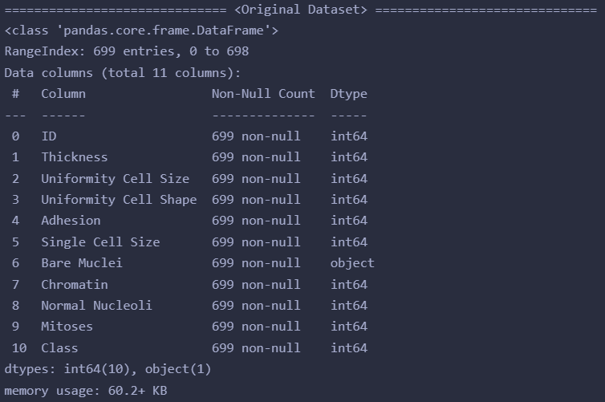

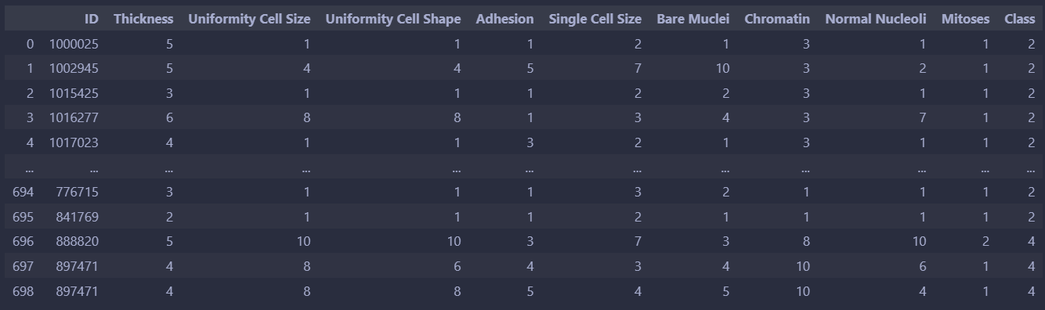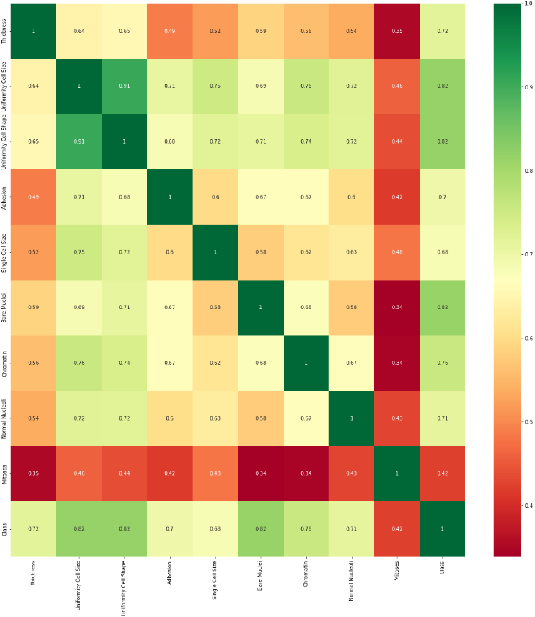

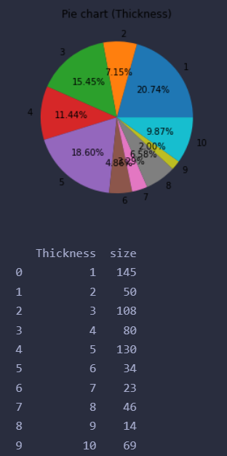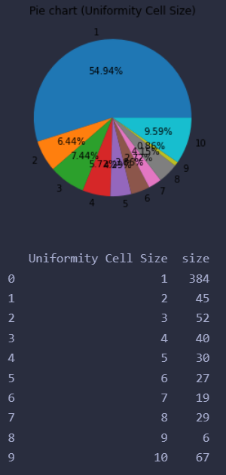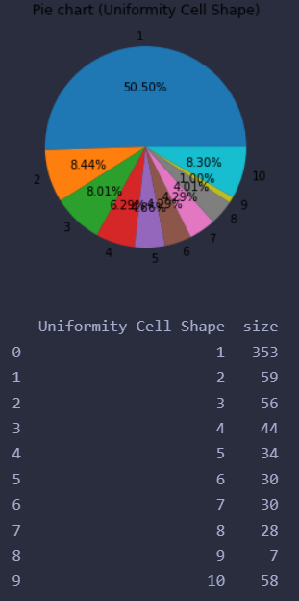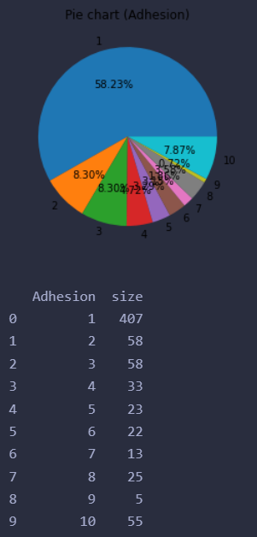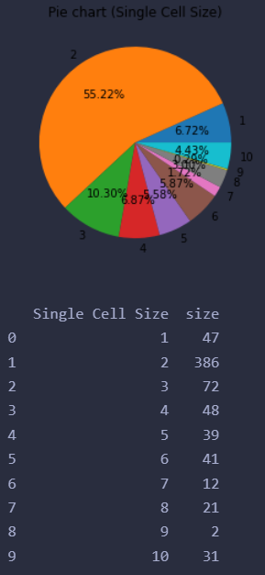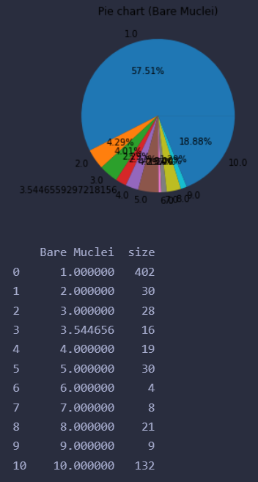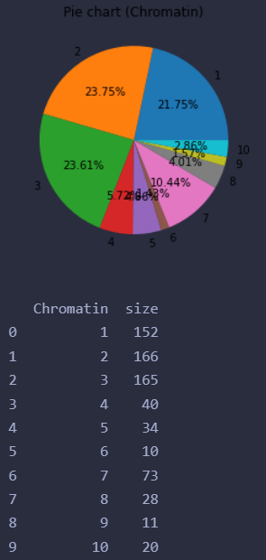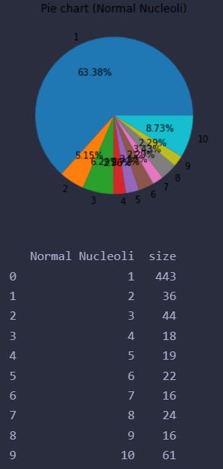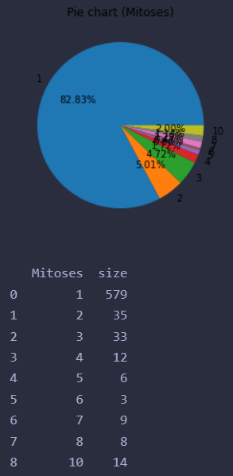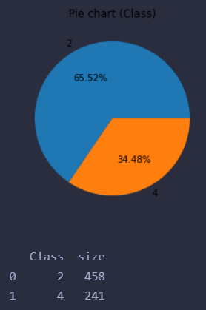

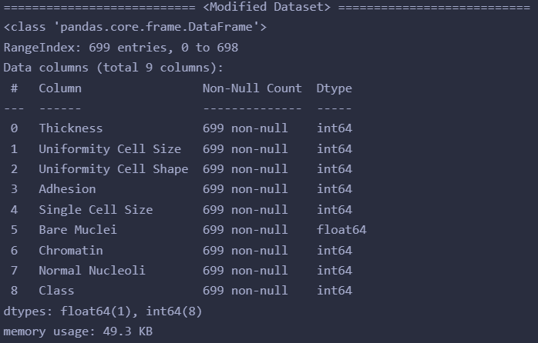

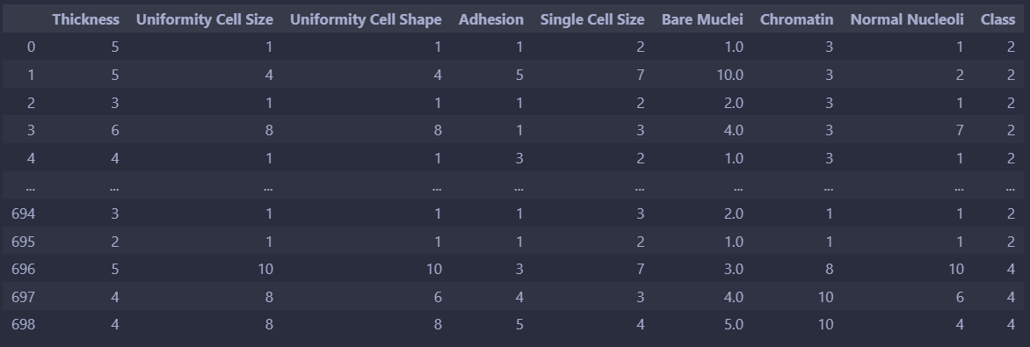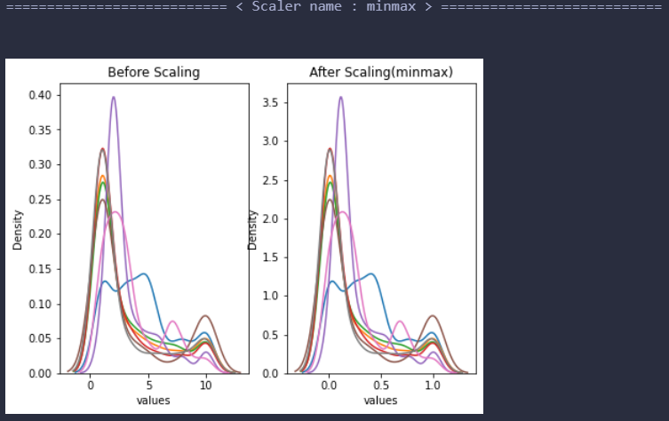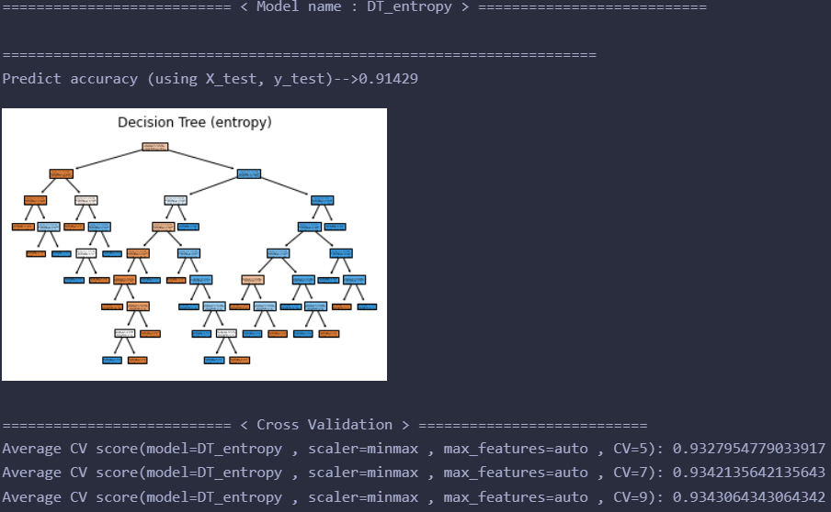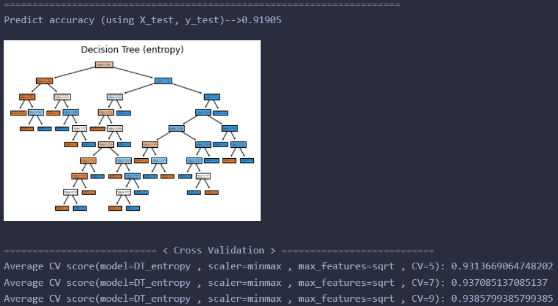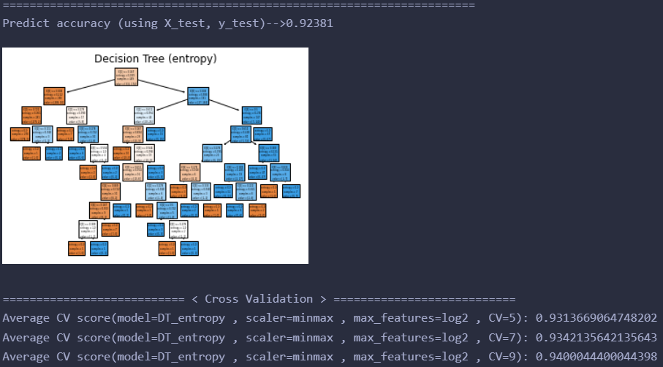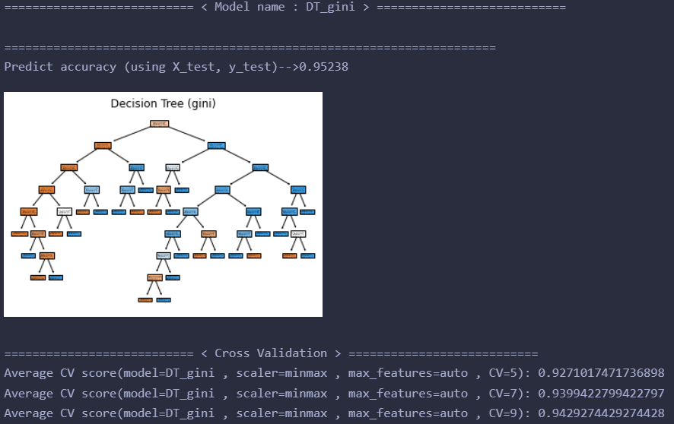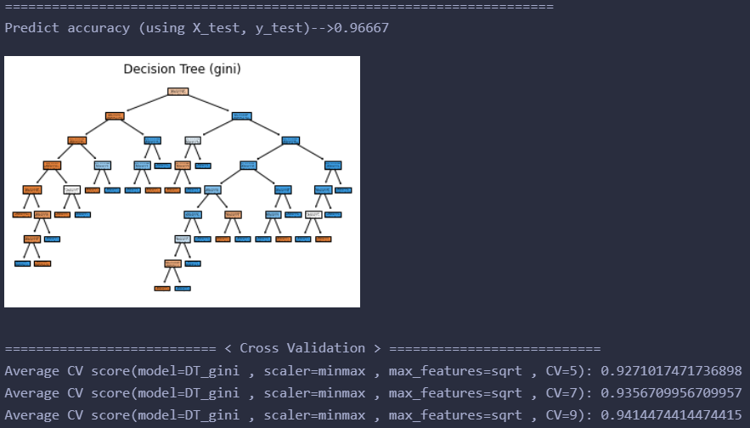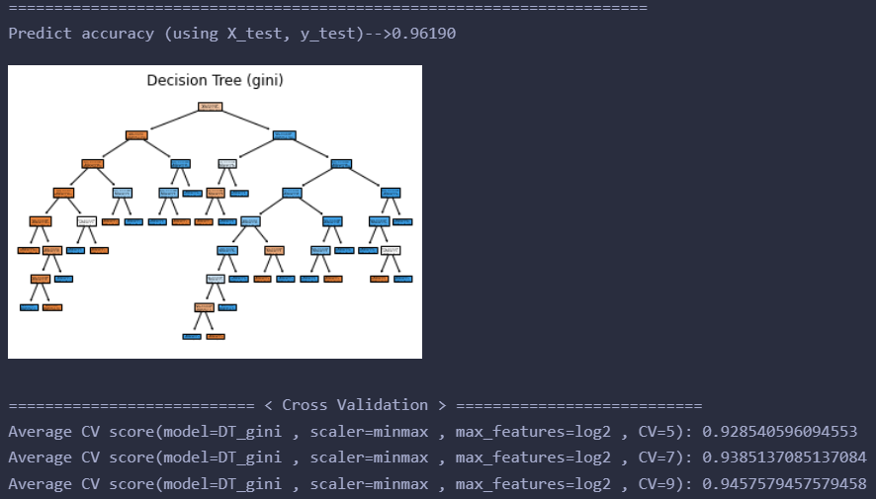

=========================== < Model name : SVM > ===========================

======================================================================

Predict accuracy (using X_test, y_test)-->0.95714

=========================== < Cross Validation > ===========================

Average CV score(model=SVM , scaler=minmax , kernel=linear , gamma=0.001 , C=0.01 , CV=5): 0.95

Average CV score(model=SVM , scaler=minmax , kernel=linear , gamma=0.001 , C=0.01 , CV=7): 0.9528571428571428

Average CV score(model=SVM , scaler=minmax , kernel=linear , gamma=0.001 , C=0.01 , CV=9): 0.9529729529729529

======================================================================

Predict accuracy (using X_test, y_test)-->0.96190

=========================== < Cross Validation > ===========================

Average CV score(model=SVM , scaler=minmax , kernel=linear , gamma=0.001 , C=0.1 , CV=5): 0.9585714285714285

Average CV score(model=SVM , scaler=minmax , kernel=linear , gamma=0.001 , C=0.1 , CV=7): 0.9614285714285714

Average CV score(model=SVM , scaler=minmax , kernel=linear , gamma=0.001 , C=0.1 , CV=9): 0.9629444629444629

======================================================================

Predict accuracy (using X_test, y_test)-->0.97143

=========================== < Cross Validation > ===========================

Average CV score(model=SVM , scaler=minmax , kernel=linear , gamma=0.001 , C=1 , CV=5): 0.9642857142857142

Average CV score(model=SVM , scaler=minmax , kernel=linear , gamma=0.001 , C=1 , CV=7): 0.9671428571428571

Average CV score(model=SVM , scaler=minmax , kernel=linear , gamma=0.001 , C=1 , CV=9): 0.9657749657749659

======================================================================

Predict accuracy (using X_test, y_test)-->0.95714

=========================== < Cross Validation > ===========================

Average CV score(model=SVM , scaler=minmax , kernel=linear , gamma=0.01 , C=0.01 , CV=5): 0.95

Average CV score(model=SVM , scaler=minmax , kernel=linear , gamma=0.01 , C=0.01 , CV=7): 0.9528571428571428

Average CV score(model=SVM , scaler=minmax , kernel=linear , gamma=0.01 , C=0.01 , CV=9): 0.9529729529729529

======================================================================

Predict accuracy (using X_test, y_test)-->0.96190

=========================== < Cross Validation > ===========================

Average CV score(model=SVM , scaler=minmax , kernel=linear , gamma=0.01 , C=0.1 , CV=5): 0.9585714285714285

Average CV score(model=SVM , scaler=minmax , kernel=linear , gamma=0.01 , C=0.1 , CV=7): 0.9614285714285714

Average CV score(model=SVM , scaler=minmax , kernel=linear , gamma=0.01 , C=0.1 , CV=9): 0.9629444629444629

======================================================================

Predict accuracy (using X_test, y_test)-->0.97143

=========================== < Cross Validation > ===========================

Average CV score(model=SVM , scaler=minmax , kernel=linear , gamma=0.01 , C=1 , CV=5): 0.9642857142857142

Average CV score(model=SVM , scaler=minmax , kernel=linear , gamma=0.01 , C=1 , CV=7): 0.9671428571428571

Average CV score(model=SVM , scaler=minmax , kernel=linear , gamma=0.01 , C=1 , CV=9): 0.9657749657749659

======================================================================

Predict accuracy (using X_test, y_test)-->0.95714

=========================== < Cross Validation > ===========================

Average CV score(model=SVM , scaler=minmax , kernel=linear , gamma=0.1 , C=0.01 , CV=5): 0.95

Average CV score(model=SVM , scaler=minmax , kernel=linear , gamma=0.1 , C=0.01 , CV=7): 0.9528571428571428

Average CV score(model=SVM , scaler=minmax , kernel=linear , gamma=0.1 , C=0.01 , CV=9): 0.9529729529729529

======================================================================

Predict accuracy (using X_test, y_test)-->0.96190

=========================== < Cross Validation > ===========================

Average CV score(model=SVM , scaler=minmax , kernel=linear , gamma=0.1 , C=0.1 , CV=5): 0.9585714285714285

Average CV score(model=SVM , scaler=minmax , kernel=linear , gamma=0.1 , C=0.1 , CV=7): 0.9614285714285714

Average CV score(model=SVM , scaler=minmax , kernel=linear , gamma=0.1 , C=0.1 , CV=9): 0.9629444629444629

======================================================================

Predict accuracy (using X_test, y_test)-->0.97143

=========================== < Cross Validation > ===========================

Average CV score(model=SVM , scaler=minmax , kernel=linear , gamma=0.1 , C=1 , CV=5): 0.9642857142857142

Average CV score(model=SVM , scaler=minmax , kernel=linear , gamma=0.1 , C=1 , CV=7): 0.9671428571428571

Average CV score(model=SVM , scaler=minmax , kernel=linear , gamma=0.1 , C=1 , CV=9): 0.9657749657749659

======================================================================

Predict accuracy (using X_test, y_test)-->0.95714

=========================== < Cross Validation > ===========================

Average CV score(model=SVM , scaler=minmax , kernel=linear , gamma=1 , C=0.01 , CV=5): 0.95

Average CV score(model=SVM , scaler=minmax , kernel=linear , gamma=1 , C=0.01 , CV=7): 0.9528571428571428

Average CV score(model=SVM , scaler=minmax , kernel=linear , gamma=1 , C=0.01 , CV=9): 0.9529729529729529

======================================================================

Predict accuracy (using X_test, y_test)-->0.96190

=========================== < Cross Validation > ===========================

Average CV score(model=SVM , scaler=minmax , kernel=linear , gamma=1 , C=0.1 , CV=5): 0.9585714285714285

Average CV score(model=SVM , scaler=minmax , kernel=linear , gamma=1 , C=0.1 , CV=7): 0.9614285714285714

Average CV score(model=SVM , scaler=minmax , kernel=linear , gamma=1 , C=0.1 , CV=9): 0.9629444629444629

======================================================================

Predict accuracy (using X_test, y_test)-->0.97143

=========================== < Cross Validation > ===========================

Average CV score(model=SVM , scaler=minmax , kernel=linear , gamma=1 , C=1 , CV=5): 0.9642857142857142

Average CV score(model=SVM , scaler=minmax , kernel=linear , gamma=1 , C=1 , CV=7): 0.9671428571428571

Average CV score(model=SVM , scaler=minmax , kernel=linear , gamma=1 , C=1 , CV=9): 0.9657749657749659

======================================================================

Predict accuracy (using X_test, y_test)-->0.95714

=========================== < Cross Validation > ===========================

Average CV score(model=SVM , scaler=minmax , kernel=linear , gamma=10 , C=0.01 , CV=5): 0.95

Average CV score(model=SVM , scaler=minmax , kernel=linear , gamma=10 , C=0.01 , CV=7): 0.9528571428571428

Average CV score(model=SVM , scaler=minmax , kernel=linear , gamma=10 , C=0.01 , CV=9): 0.9529729529729529

======================================================================

Predict accuracy (using X_test, y_test)-->0.96190

=========================== < Cross Validation > ===========================

Average CV score(model=SVM , scaler=minmax , kernel=linear , gamma=10 , C=0.1 , CV=5): 0.9585714285714285

Average CV score(model=SVM , scaler=minmax , kernel=linear , gamma=10 , C=0.1 , CV=7): 0.9614285714285714

Average CV score(model=SVM , scaler=minmax , kernel=linear , gamma=10 , C=0.1 , CV=9): 0.9629444629444629

======================================================================

Predict accuracy (using X_test, y_test)-->0.97143

=========================== < Cross Validation > ===========================

Average CV score(model=SVM , scaler=minmax , kernel=linear , gamma=10 , C=1 , CV=5): 0.9642857142857142

Average CV score(model=SVM , scaler=minmax , kernel=linear , gamma=10 , C=1 , CV=7): 0.9671428571428571

Average CV score(model=SVM , scaler=minmax , kernel=linear , gamma=10 , C=1 , CV=9): 0.9657749657749659

======================================================================

Predict accuracy (using X_test, y_test)-->0.68095

=========================== < Cross Validation > ===========================

Average CV score(model=SVM , scaler=minmax , kernel=poly , gamma=0.001 , C=0.01 , CV=5): 0.6553545734840698

Average CV score(model=SVM , scaler=minmax , kernel=poly , gamma=0.001 , C=0.01 , CV=7): 0.6554112554112554

Average CV score(model=SVM , scaler=minmax , kernel=poly , gamma=0.001 , C=0.01 , CV=9): 0.6557331557331557

======================================================================

Predict accuracy (using X_test, y_test)-->0.68095

=========================== < Cross Validation > ===========================

Average CV score(model=SVM , scaler=minmax , kernel=poly , gamma=0.001 , C=0.1 , CV=5): 0.6553545734840698

Average CV score(model=SVM , scaler=minmax , kernel=poly , gamma=0.001 , C=0.1 , CV=7): 0.6554112554112554

Average CV score(model=SVM , scaler=minmax , kernel=poly , gamma=0.001 , C=0.1 , CV=9): 0.6557331557331557

======================================================================

Predict accuracy (using X_test, y_test)-->0.68095

=========================== < Cross Validation > ===========================

Average CV score(model=SVM , scaler=minmax , kernel=poly , gamma=0.001 , C=1 , CV=5): 0.6553545734840698

Average CV score(model=SVM , scaler=minmax , kernel=poly , gamma=0.001 , C=1 , CV=7): 0.6554112554112554

Average CV score(model=SVM , scaler=minmax , kernel=poly , gamma=0.001 , C=1 , CV=9): 0.6557331557331557

======================================================================

Predict accuracy (using X_test, y_test)-->0.68095

=========================== < Cross Validation > ===========================

Average CV score(model=SVM , scaler=minmax , kernel=poly , gamma=0.01 , C=0.01 , CV=5): 0.6553545734840698

Average CV score(model=SVM , scaler=minmax , kernel=poly , gamma=0.01 , C=0.01 , CV=7): 0.6554112554112554

Average CV score(model=SVM , scaler=minmax , kernel=poly , gamma=0.01 , C=0.01 , CV=9): 0.6557331557331557

======================================================================

Predict accuracy (using X_test, y_test)-->0.68095

=========================== < Cross Validation > ===========================

Average CV score(model=SVM , scaler=minmax , kernel=poly , gamma=0.01 , C=0.1 , CV=5): 0.6553545734840698

Average CV score(model=SVM , scaler=minmax , kernel=poly , gamma=0.01 , C=0.1 , CV=7): 0.6554112554112554

Average CV score(model=SVM , scaler=minmax , kernel=poly , gamma=0.01 , C=0.1 , CV=9): 0.6557331557331557

======================================================================

Predict accuracy (using X_test, y_test)-->0.68095

=========================== < Cross Validation > ===========================

Average CV score(model=SVM , scaler=minmax , kernel=poly , gamma=0.01 , C=1 , CV=5): 0.6553545734840698

Average CV score(model=SVM , scaler=minmax , kernel=poly , gamma=0.01 , C=1 , CV=7): 0.6554112554112554

Average CV score(model=SVM , scaler=minmax , kernel=poly , gamma=0.01 , C=1 , CV=9): 0.6557331557331557

======================================================================

Predict accuracy (using X_test, y_test)-->0.68095

=========================== < Cross Validation > ===========================

Average CV score(model=SVM , scaler=minmax , kernel=poly , gamma=0.1 , C=0.01 , CV=5): 0.6553545734840698

Average CV score(model=SVM , scaler=minmax , kernel=poly , gamma=0.1 , C=0.01 , CV=7): 0.6554112554112554

Average CV score(model=SVM , scaler=minmax , kernel=poly , gamma=0.1 , C=0.01 , CV=9): 0.6557331557331557

======================================================================

Predict accuracy (using X_test, y_test)-->0.72381

=========================== < Cross Validation > ===========================

Average CV score(model=SVM , scaler=minmax , kernel=poly , gamma=0.1 , C=0.1 , CV=5): 0.7154573484069887

Average CV score(model=SVM , scaler=minmax , kernel=poly , gamma=0.1 , C=0.1 , CV=7): 0.7226406926406926

Average CV score(model=SVM , scaler=minmax , kernel=poly , gamma=0.1 , C=0.1 , CV=9): 0.7272727272727272

======================================================================

Predict accuracy (using X_test, y_test)-->0.90952

=========================== < Cross Validation > ===========================

Average CV score(model=SVM , scaler=minmax , kernel=poly , gamma=0.1 , C=1 , CV=5): 0.9013566289825283

Average CV score(model=SVM , scaler=minmax , kernel=poly , gamma=0.1 , C=1 , CV=7): 0.9042279942279942

Average CV score(model=SVM , scaler=minmax , kernel=poly , gamma=0.1 , C=1 , CV=9): 0.9072224072224072

======================================================================

Predict accuracy (using X_test, y_test)-->0.94286

=========================== < Cross Validation > ===========================

Average CV score(model=SVM , scaler=minmax , kernel=poly , gamma=1 , C=0.01 , CV=5): 0.9399794450154163

Average CV score(model=SVM , scaler=minmax , kernel=poly , gamma=1 , C=0.01 , CV=7): 0.9428427128427128

Average CV score(model=SVM , scaler=minmax , kernel=poly , gamma=1 , C=0.01 , CV=9): 0.9458319458319457

======================================================================

Predict accuracy (using X_test, y_test)-->0.96190

=========================== < Cross Validation > ===========================

Average CV score(model=SVM , scaler=minmax , kernel=poly , gamma=1 , C=0.1 , CV=5): 0.9514285714285714

Average CV score(model=SVM , scaler=minmax , kernel=poly , gamma=1 , C=0.1 , CV=7): 0.9557142857142856

Average CV score(model=SVM , scaler=minmax , kernel=poly , gamma=1 , C=0.1 , CV=9): 0.9543789543789545

======================================================================

Predict accuracy (using X_test, y_test)-->0.96667

=========================== < Cross Validation > ===========================

Average CV score(model=SVM , scaler=minmax , kernel=poly , gamma=1 , C=1 , CV=5): 0.9528365878725591

Average CV score(model=SVM , scaler=minmax , kernel=poly , gamma=1 , C=1 , CV=7): 0.9542568542568542

Average CV score(model=SVM , scaler=minmax , kernel=poly , gamma=1 , C=1 , CV=9): 0.9529174529174528

======================================================================

Predict accuracy (using X_test, y_test)-->0.92857

=========================== < Cross Validation > ===========================

Average CV score(model=SVM , scaler=minmax , kernel=poly , gamma=10 , C=0.01 , CV=5): 0.9385097636176774

Average CV score(model=SVM , scaler=minmax , kernel=poly , gamma=10 , C=0.01 , CV=7): 0.9356421356421357

Average CV score(model=SVM , scaler=minmax , kernel=poly , gamma=10 , C=0.01 , CV=9): 0.9343249343249342

======================================================================

Predict accuracy (using X_test, y_test)-->0.93333

=========================== < Cross Validation > ===========================

Average CV score(model=SVM , scaler=minmax , kernel=poly , gamma=10 , C=0.1 , CV=5): 0.9399486125385407

Average CV score(model=SVM , scaler=minmax , kernel=poly , gamma=10 , C=0.1 , CV=7): 0.937085137085137

Average CV score(model=SVM , scaler=minmax , kernel=poly , gamma=10 , C=0.1 , CV=9): 0.9386169386169385

======================================================================

Predict accuracy (using X_test, y_test)-->0.92381

=========================== < Cross Validation > ===========================

Average CV score(model=SVM , scaler=minmax , kernel=poly , gamma=10 , C=1 , CV=5): 0.9328263103802673

Average CV score(model=SVM , scaler=minmax , kernel=poly , gamma=10 , C=1 , CV=7): 0.9328282828282829

Average CV score(model=SVM , scaler=minmax , kernel=poly , gamma=10 , C=1 , CV=9): 0.9343619343619345

======================================================================

Predict accuracy (using X_test, y_test)-->0.68095

=========================== < Cross Validation > ===========================

Average CV score(model=SVM , scaler=minmax , kernel=rbf , gamma=0.001 , C=0.01 , CV=5): 0.6553545734840698

Average CV score(model=SVM , scaler=minmax , kernel=rbf , gamma=0.001 , C=0.01 , CV=7): 0.6554112554112554

Average CV score(model=SVM , scaler=minmax , kernel=rbf , gamma=0.001 , C=0.01 , CV=9): 0.6557331557331557

======================================================================

Predict accuracy (using X_test, y_test)-->0.68095

=========================== < Cross Validation > ===========================

Average CV score(model=SVM , scaler=minmax , kernel=rbf , gamma=0.001 , C=0.1 , CV=5): 0.6553545734840698

Average CV score(model=SVM , scaler=minmax , kernel=rbf , gamma=0.001 , C=0.1 , CV=7): 0.6554112554112554

Average CV score(model=SVM , scaler=minmax , kernel=rbf , gamma=0.001 , C=0.1 , CV=9): 0.6557331557331557

======================================================================

Predict accuracy (using X_test, y_test)-->0.71905

=========================== < Cross Validation > ===========================

Average CV score(model=SVM , scaler=minmax , kernel=rbf , gamma=0.001 , C=1 , CV=5): 0.7154676258992806

Average CV score(model=SVM , scaler=minmax , kernel=rbf , gamma=0.001 , C=1 , CV=7): 0.7483838383838383

Average CV score(model=SVM , scaler=minmax , kernel=rbf , gamma=0.001 , C=1 , CV=9): 0.7644577644577644

======================================================================

Predict accuracy (using X_test, y_test)-->0.68095

=========================== < Cross Validation > ===========================

Average CV score(model=SVM , scaler=minmax , kernel=rbf , gamma=0.01 , C=0.01 , CV=5): 0.6553545734840698

Average CV score(model=SVM , scaler=minmax , kernel=rbf , gamma=0.01 , C=0.01 , CV=7): 0.6554112554112554

Average CV score(model=SVM , scaler=minmax , kernel=rbf , gamma=0.01 , C=0.01 , CV=9): 0.6557331557331557

======================================================================

Predict accuracy (using X_test, y_test)-->0.71905

=========================== < Cross Validation > ===========================

Average CV score(model=SVM , scaler=minmax , kernel=rbf , gamma=0.01 , C=0.1 , CV=5): 0.7111716341212745

Average CV score(model=SVM , scaler=minmax , kernel=rbf , gamma=0.01 , C=0.1 , CV=7): 0.7398124098124097

Average CV score(model=SVM , scaler=minmax , kernel=rbf , gamma=0.01 , C=0.1 , CV=9): 0.7487327487327488

======================================================================

Predict accuracy (using X_test, y_test)-->0.95714

=========================== < Cross Validation > ===========================

Average CV score(model=SVM , scaler=minmax , kernel=rbf , gamma=0.01 , C=1 , CV=5): 0.9585714285714285

Average CV score(model=SVM , scaler=minmax , kernel=rbf , gamma=0.01 , C=1 , CV=7): 0.9585714285714285

Average CV score(model=SVM , scaler=minmax , kernel=rbf , gamma=0.01 , C=1 , CV=9): 0.9586709586709586

======================================================================

Predict accuracy (using X_test, y_test)-->0.68095

=========================== < Cross Validation > ===========================

Average CV score(model=SVM , scaler=minmax , kernel=rbf , gamma=0.1 , C=0.01 , CV=5): 0.6625282631038026

Average CV score(model=SVM , scaler=minmax , kernel=rbf , gamma=0.1 , C=0.01 , CV=7): 0.6697258297258297

Average CV score(model=SVM , scaler=minmax , kernel=rbf , gamma=0.1 , C=0.01 , CV=9): 0.6714951714951716

======================================================================

Predict accuracy (using X_test, y_test)-->0.96190

=========================== < Cross Validation > ===========================

Average CV score(model=SVM , scaler=minmax , kernel=rbf , gamma=0.1 , C=0.1 , CV=5): 0.9585714285714285

Average CV score(model=SVM , scaler=minmax , kernel=rbf , gamma=0.1 , C=0.1 , CV=7): 0.9585714285714285

Average CV score(model=SVM , scaler=minmax , kernel=rbf , gamma=0.1 , C=0.1 , CV=9): 0.9586709586709586

======================================================================

Predict accuracy (using X_test, y_test)-->0.96190

=========================== < Cross Validation > ===========================

Average CV score(model=SVM , scaler=minmax , kernel=rbf , gamma=0.1 , C=1 , CV=5): 0.9600000000000002

Average CV score(model=SVM , scaler=minmax , kernel=rbf , gamma=0.1 , C=1 , CV=7): 0.9614285714285714

Average CV score(model=SVM , scaler=minmax , kernel=rbf , gamma=0.1 , C=1 , CV=9): 0.9629444629444629

======================================================================

Predict accuracy (using X_test, y_test)-->0.96667

=========================== < Cross Validation > ===========================

Average CV score(model=SVM , scaler=minmax , kernel=rbf , gamma=1 , C=0.01 , CV=5): 0.9628468653648511

Average CV score(model=SVM , scaler=minmax , kernel=rbf , gamma=1 , C=0.01 , CV=7): 0.9628427128427128

Average CV score(model=SVM , scaler=minmax , kernel=rbf , gamma=1 , C=0.01 , CV=9): 0.962907462907463

======================================================================

Predict accuracy (using X_test, y_test)-->0.96190

=========================== < Cross Validation > ===========================

Average CV score(model=SVM , scaler=minmax , kernel=rbf , gamma=1 , C=0.1 , CV=5): 0.9628468653648511

Average CV score(model=SVM , scaler=minmax , kernel=rbf , gamma=1 , C=0.1 , CV=7): 0.9642712842712842

Average CV score(model=SVM , scaler=minmax , kernel=rbf , gamma=1 , C=0.1 , CV=9): 0.9643319643319644

======================================================================

Predict accuracy (using X_test, y_test)-->0.97143

=========================== < Cross Validation > ===========================

Average CV score(model=SVM , scaler=minmax , kernel=rbf , gamma=1 , C=1 , CV=5): 0.9599897225077083

Average CV score(model=SVM , scaler=minmax , kernel=rbf , gamma=1 , C=1 , CV=7): 0.9628427128427128

Average CV score(model=SVM , scaler=minmax , kernel=rbf , gamma=1 , C=1 , CV=9): 0.9643319643319644

======================================================================

Predict accuracy (using X_test, y_test)-->0.68095

=========================== < Cross Validation > ===========================

Average CV score(model=SVM , scaler=minmax , kernel=rbf , gamma=10 , C=0.01 , CV=5): 0.6553545734840698

Average CV score(model=SVM , scaler=minmax , kernel=rbf , gamma=10 , C=0.01 , CV=7): 0.6554112554112554

Average CV score(model=SVM , scaler=minmax , kernel=rbf , gamma=10 , C=0.01 , CV=9): 0.6557331557331557

======================================================================

Predict accuracy (using X_test, y_test)-->0.94286

=========================== < Cross Validation > ===========================

Average CV score(model=SVM , scaler=minmax , kernel=rbf , gamma=10 , C=0.1 , CV=5): 0.9413977389516959

Average CV score(model=SVM , scaler=minmax , kernel=rbf , gamma=10 , C=0.1 , CV=7): 0.9413997113997115

Average CV score(model=SVM , scaler=minmax , kernel=rbf , gamma=10 , C=0.1 , CV=9): 0.9414844414844415

======================================================================

Predict accuracy (using X_test, y_test)-->0.95714

=========================== < Cross Validation > ===========================

Average CV score(model=SVM , scaler=minmax , kernel=rbf , gamma=10 , C=1 , CV=5): 0.9499794450154162

Average CV score(model=SVM , scaler=minmax , kernel=rbf , gamma=10 , C=1 , CV=7): 0.9528282828282829

Average CV score(model=SVM , scaler=minmax , kernel=rbf , gamma=10 , C=1 , CV=9): 0.9543234543234544

======================================================================

Predict accuracy (using X_test, y_test)-->0.68095

=========================== < Cross Validation > ===========================

Average CV score(model=SVM , scaler=minmax , kernel=sigmoid , gamma=0.001 , C=0.01 , CV=5): 0.6553545734840698

Average CV score(model=SVM , scaler=minmax , kernel=sigmoid , gamma=0.001 , C=0.01 , CV=7): 0.6554112554112554

Average CV score(model=SVM , scaler=minmax , kernel=sigmoid , gamma=0.001 , C=0.01 , CV=9): 0.6557331557331557

======================================================================

Predict accuracy (using X_test, y_test)-->0.68095

=========================== < Cross Validation > ===========================

Average CV score(model=SVM , scaler=minmax , kernel=sigmoid , gamma=0.001 , C=0.1 , CV=5): 0.6553545734840698

Average CV score(model=SVM , scaler=minmax , kernel=sigmoid , gamma=0.001 , C=0.1 , CV=7): 0.6554112554112554

Average CV score(model=SVM , scaler=minmax , kernel=sigmoid , gamma=0.001 , C=0.1 , CV=9): 0.6557331557331557

======================================================================

Predict accuracy (using X_test, y_test)-->0.68095

=========================== < Cross Validation > ===========================

Average CV score(model=SVM , scaler=minmax , kernel=sigmoid , gamma=0.001 , C=1 , CV=5): 0.6553545734840698

Average CV score(model=SVM , scaler=minmax , kernel=sigmoid , gamma=0.001 , C=1 , CV=7): 0.6554112554112554

Average CV score(model=SVM , scaler=minmax , kernel=sigmoid , gamma=0.001 , C=1 , CV=9): 0.6557331557331557

======================================================================

Predict accuracy (using X_test, y_test)-->0.68095

=========================== < Cross Validation > ===========================

Average CV score(model=SVM , scaler=minmax , kernel=sigmoid , gamma=0.01 , C=0.01 , CV=5): 0.6553545734840698

Average CV score(model=SVM , scaler=minmax , kernel=sigmoid , gamma=0.01 , C=0.01 , CV=7): 0.6554112554112554

Average CV score(model=SVM , scaler=minmax , kernel=sigmoid , gamma=0.01 , C=0.01 , CV=9): 0.6557331557331557

======================================================================

Predict accuracy (using X_test, y_test)-->0.68095

=========================== < Cross Validation > ===========================

Average CV score(model=SVM , scaler=minmax , kernel=sigmoid , gamma=0.01 , C=0.1 , CV=5): 0.6553545734840698

Average CV score(model=SVM , scaler=minmax , kernel=sigmoid , gamma=0.01 , C=0.1 , CV=7): 0.6554112554112554

Average CV score(model=SVM , scaler=minmax , kernel=sigmoid , gamma=0.01 , C=0.1 , CV=9): 0.6557331557331557

======================================================================

Predict accuracy (using X_test, y_test)-->0.95714

=========================== < Cross Validation > ===========================

Average CV score(model=SVM , scaler=minmax , kernel=sigmoid , gamma=0.01 , C=1 , CV=5): 0.95

Average CV score(model=SVM , scaler=minmax , kernel=sigmoid , gamma=0.01 , C=1 , CV=7): 0.9528571428571428

Average CV score(model=SVM , scaler=minmax , kernel=sigmoid , gamma=0.01 , C=1 , CV=9): 0.9529729529729529

======================================================================

Predict accuracy (using X_test, y_test)-->0.68095

=========================== < Cross Validation > ===========================

Average CV score(model=SVM , scaler=minmax , kernel=sigmoid , gamma=0.1 , C=0.01 , CV=5): 0.6553545734840698

Average CV score(model=SVM , scaler=minmax , kernel=sigmoid , gamma=0.1 , C=0.01 , CV=7): 0.6554112554112554

Average CV score(model=SVM , scaler=minmax , kernel=sigmoid , gamma=0.1 , C=0.01 , CV=9): 0.6557331557331557

======================================================================

Predict accuracy (using X_test, y_test)-->0.95714

=========================== < Cross Validation > ===========================

Average CV score(model=SVM , scaler=minmax , kernel=sigmoid , gamma=0.1 , C=0.1 , CV=5): 0.9542857142857144

Average CV score(model=SVM , scaler=minmax , kernel=sigmoid , gamma=0.1 , C=0.1 , CV=7): 0.9542857142857143

Average CV score(model=SVM , scaler=minmax , kernel=sigmoid , gamma=0.1 , C=0.1 , CV=9): 0.9543974543974544

======================================================================

Predict accuracy (using X_test, y_test)-->0.96190

=========================== < Cross Validation > ===========================

Average CV score(model=SVM , scaler=minmax , kernel=sigmoid , gamma=0.1 , C=1 , CV=5): 0.9600000000000002

Average CV score(model=SVM , scaler=minmax , kernel=sigmoid , gamma=0.1 , C=1 , CV=7): 0.9628571428571427

Average CV score(model=SVM , scaler=minmax , kernel=sigmoid , gamma=0.1 , C=1 , CV=9): 0.9629444629444629

======================================================================

Predict accuracy (using X_test, y_test)-->0.68095

=========================== < Cross Validation > ===========================

Average CV score(model=SVM , scaler=minmax , kernel=sigmoid , gamma=1 , C=0.01 , CV=5): 0.6567831449126412

Average CV score(model=SVM , scaler=minmax , kernel=sigmoid , gamma=1 , C=0.01 , CV=7): 0.6568398268398268

Average CV score(model=SVM , scaler=minmax , kernel=sigmoid , gamma=1 , C=0.01 , CV=9): 0.6571761571761572

======================================================================

Predict accuracy (using X_test, y_test)-->0.81429

=========================== < Cross Validation > ===========================

Average CV score(model=SVM , scaler=minmax , kernel=sigmoid , gamma=1 , C=0.1 , CV=5): 0.7940801644398766

Average CV score(model=SVM , scaler=minmax , kernel=sigmoid , gamma=1 , C=0.1 , CV=7): 0.7926551226551227

Average CV score(model=SVM , scaler=minmax , kernel=sigmoid , gamma=1 , C=0.1 , CV=9): 0.79004329004329

======================================================================

Predict accuracy (using X_test, y_test)-->0.72857

=========================== < Cross Validation > ===========================

Average CV score(model=SVM , scaler=minmax , kernel=sigmoid , gamma=1 , C=1 , CV=5): 0.7125693730729702

Average CV score(model=SVM , scaler=minmax , kernel=sigmoid , gamma=1 , C=1 , CV=7): 0.7211688311688312

Average CV score(model=SVM , scaler=minmax , kernel=sigmoid , gamma=1 , C=1 , CV=9): 0.7186147186147187

======================================================================

Predict accuracy (using X_test, y_test)-->0.68095

=========================== < Cross Validation > ===========================

Average CV score(model=SVM , scaler=minmax , kernel=sigmoid , gamma=10 , C=0.01 , CV=5): 0.6553545734840698

Average CV score(model=SVM , scaler=minmax , kernel=sigmoid , gamma=10 , C=0.01 , CV=7): 0.6554112554112554

Average CV score(model=SVM , scaler=minmax , kernel=sigmoid , gamma=10 , C=0.01 , CV=9): 0.6557331557331557

======================================================================

Predict accuracy (using X_test, y_test)-->0.40000

=========================== < Cross Validation > ===========================

Average CV score(model=SVM , scaler=minmax , kernel=sigmoid , gamma=10 , C=0.1 , CV=5): 0.38770811921891063

Average CV score(model=SVM , scaler=minmax , kernel=sigmoid , gamma=10 , C=0.1 , CV=7): 0.3862770562770562

Average CV score(model=SVM , scaler=minmax , kernel=sigmoid , gamma=10 , C=0.1 , CV=9): 0.37514337514337515

======================================================================

Predict accuracy (using X_test, y_test)-->0.32381

=========================== < Cross Validation > ===========================

Average CV score(model=SVM , scaler=minmax , kernel=sigmoid , gamma=10 , C=1 , CV=5): 0.28475847893114076

Average CV score(model=SVM , scaler=minmax , kernel=sigmoid , gamma=10 , C=1 , CV=7): 0.29903318903318904

Average CV score(model=SVM , scaler=minmax , kernel=sigmoid , gamma=10 , C=1 , CV=9): 0.291985791985792

=========================== < Model name : logistic_regression > ===========================

======================================================================

Predict accuracy (using X_test, y_test)-->0.96190

=========================== < Cross Validation > ===========================

Average CV score(model=logistic_regression , scaler=minmax , solver=newton-cg , CV=5): 0.9585714285714285

Average CV score(model=logistic_regression , scaler=minmax , solver=newton-cg , CV=7): 0.96

Average CV score(model=logistic_regression , scaler=minmax , solver=newton-cg , CV=9): 0.9600769600769602

======================================================================

Predict accuracy (using X_test, y_test)-->0.96190

=========================== < Cross Validation > ===========================

Average CV score(model=logistic_regression , scaler=minmax , solver=lbfgs , CV=5): 0.9585714285714285

Average CV score(model=logistic_regression , scaler=minmax , solver=lbfgs , CV=7): 0.96

Average CV score(model=logistic_regression , scaler=minmax , solver=lbfgs , CV=9): 0.9600769600769602

======================================================================

Predict accuracy (using X_test, y_test)-->0.96190

=========================== < Cross Validation > ===========================

Average CV score(model=logistic_regression , scaler=minmax , solver=liblinear , CV=5): 0.9585714285714285

Average CV score(model=logistic_regression , scaler=minmax , solver=liblinear , CV=7): 0.9585714285714285

Average CV score(model=logistic_regression , scaler=minmax , solver=liblinear , CV=9): 0.9586709586709586

======================================================================

Predict accuracy (using X_test, y_test)-->0.96190

=========================== < Cross Validation > ===========================

Average CV score(model=logistic_regression , scaler=minmax , solver=sag , CV=5): 0.9585714285714285

Average CV score(model=logistic_regression , scaler=minmax , solver=sag , CV=7): 0.96

Average CV score(model=logistic_regression , scaler=minmax , solver=sag , CV=9): 0.9600769600769602

======================================================================

Predict accuracy (using X_test, y_test)-->0.96190

=========================== < Cross Validation > ===========================

Average CV score(model=logistic_regression , scaler=minmax , solver=saga , CV=5): 0.9585714285714285

Average CV score(model=logistic_regression , scaler=minmax , solver=saga , CV=7): 0.96

Average CV score(model=logistic_regression , scaler=minmax , solver=saga , CV=9): 0.9600769600769602

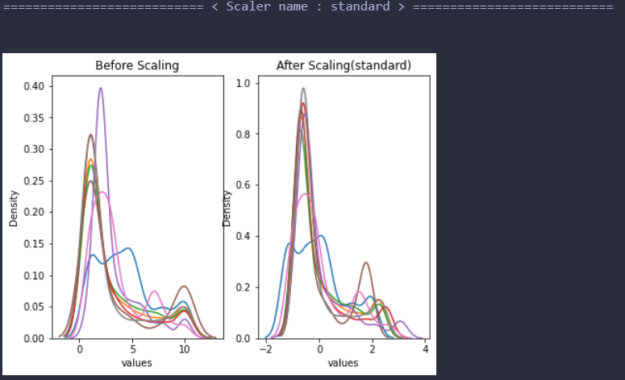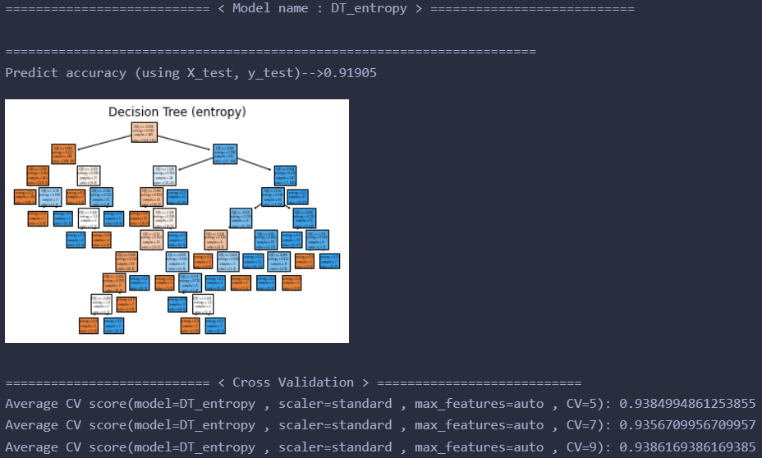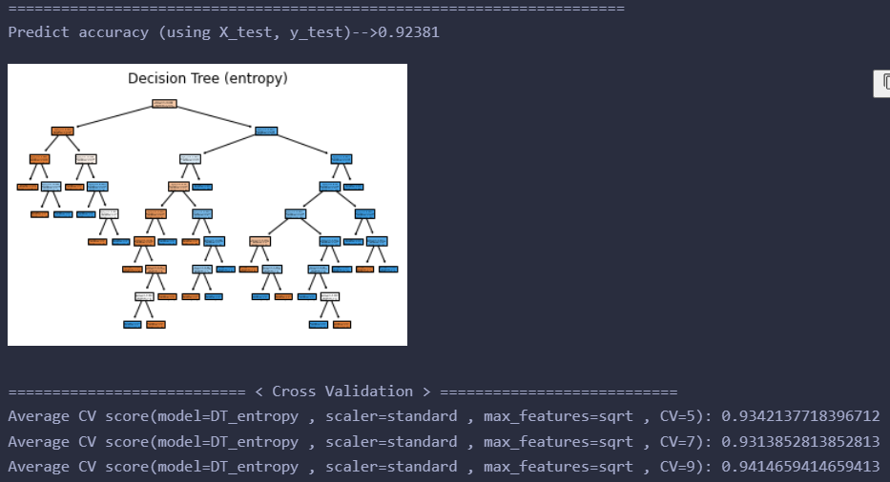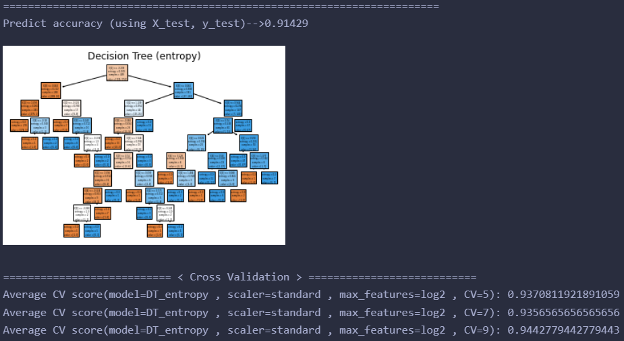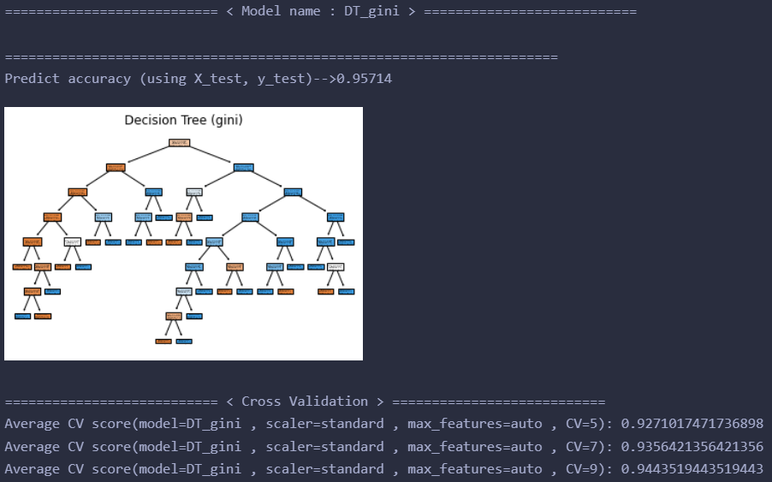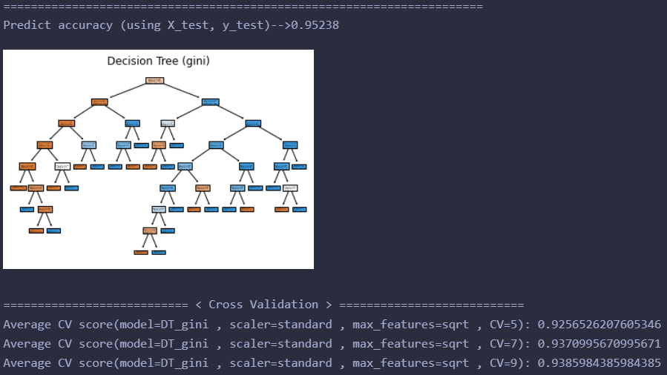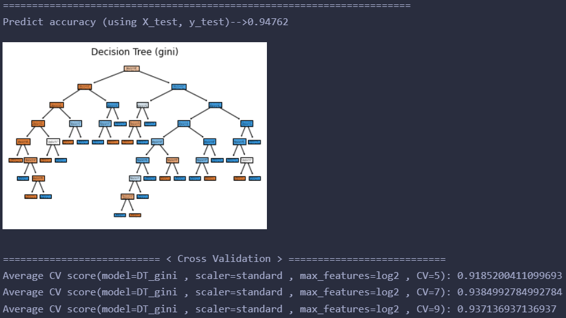

=========================== < Model name : SVM > ===========================

======================================================================

Predict accuracy (using X_test, y_test)-->0.96667

=========================== < Cross Validation > ===========================

Average CV score(model=SVM , scaler=standard , kernel=linear , gamma=0.001 , C=0.01 , CV=5): 0.9628468653648511

Average CV score(model=SVM , scaler=standard , kernel=linear , gamma=0.001 , C=0.01 , CV=7): 0.9628427128427128

Average CV score(model=SVM , scaler=standard , kernel=linear , gamma=0.001 , C=0.01 , CV=9): 0.9629259629259628

======================================================================

Predict accuracy (using X_test, y_test)-->0.97143

=========================== < Cross Validation > ===========================

Average CV score(model=SVM , scaler=standard , kernel=linear , gamma=0.001 , C=0.1 , CV=5): 0.9671428571428571

Average CV score(model=SVM , scaler=standard , kernel=linear , gamma=0.001 , C=0.1 , CV=7): 0.9671428571428571

Average CV score(model=SVM , scaler=standard , kernel=linear , gamma=0.001 , C=0.1 , CV=9): 0.967199467199467

======================================================================

Predict accuracy (using X_test, y_test)-->0.97143

=========================== < Cross Validation > ===========================

Average CV score(model=SVM , scaler=standard , kernel=linear , gamma=0.001 , C=1 , CV=5): 0.9628468653648511

Average CV score(model=SVM , scaler=standard , kernel=linear , gamma=0.001 , C=1 , CV=7): 0.9628427128427128

Average CV score(model=SVM , scaler=standard , kernel=linear , gamma=0.001 , C=1 , CV=9): 0.9657379657379658

======================================================================

Predict accuracy (using X_test, y_test)-->0.96667

=========================== < Cross Validation > ===========================

Average CV score(model=SVM , scaler=standard , kernel=linear , gamma=0.01 , C=0.01 , CV=5): 0.9628468653648511

Average CV score(model=SVM , scaler=standard , kernel=linear , gamma=0.01 , C=0.01 , CV=7): 0.9628427128427128

Average CV score(model=SVM , scaler=standard , kernel=linear , gamma=0.01 , C=0.01 , CV=9): 0.9629259629259628

======================================================================

Predict accuracy (using X_test, y_test)-->0.97143

=========================== < Cross Validation > ===========================

Average CV score(model=SVM , scaler=standard , kernel=linear , gamma=0.01 , C=0.1 , CV=5): 0.9671428571428571

Average CV score(model=SVM , scaler=standard , kernel=linear , gamma=0.01 , C=0.1 , CV=7): 0.9671428571428571

Average CV score(model=SVM , scaler=standard , kernel=linear , gamma=0.01 , C=0.1 , CV=9): 0.967199467199467

======================================================================

Predict accuracy (using X_test, y_test)-->0.97143

=========================== < Cross Validation > ===========================

Average CV score(model=SVM , scaler=standard , kernel=linear , gamma=0.01 , C=1 , CV=5): 0.9628468653648511

Average CV score(model=SVM , scaler=standard , kernel=linear , gamma=0.01 , C=1 , CV=7): 0.9628427128427128

Average CV score(model=SVM , scaler=standard , kernel=linear , gamma=0.01 , C=1 , CV=9): 0.9657379657379658

======================================================================

Predict accuracy (using X_test, y_test)-->0.96667

=========================== < Cross Validation > ===========================

Average CV score(model=SVM , scaler=standard , kernel=linear , gamma=0.1 , C=0.01 , CV=5): 0.9628468653648511

Average CV score(model=SVM , scaler=standard , kernel=linear , gamma=0.1 , C=0.01 , CV=7): 0.9628427128427128

Average CV score(model=SVM , scaler=standard , kernel=linear , gamma=0.1 , C=0.01 , CV=9): 0.9629259629259628

======================================================================

Predict accuracy (using X_test, y_test)-->0.97143

=========================== < Cross Validation > ===========================

Average CV score(model=SVM , scaler=standard , kernel=linear , gamma=0.1 , C=0.1 , CV=5): 0.9671428571428571

Average CV score(model=SVM , scaler=standard , kernel=linear , gamma=0.1 , C=0.1 , CV=7): 0.9671428571428571

Average CV score(model=SVM , scaler=standard , kernel=linear , gamma=0.1 , C=0.1 , CV=9): 0.967199467199467

======================================================================

Predict accuracy (using X_test, y_test)-->0.97143

=========================== < Cross Validation > ===========================

Average CV score(model=SVM , scaler=standard , kernel=linear , gamma=0.1 , C=1 , CV=5): 0.9628468653648511

Average CV score(model=SVM , scaler=standard , kernel=linear , gamma=0.1 , C=1 , CV=7): 0.9628427128427128

Average CV score(model=SVM , scaler=standard , kernel=linear , gamma=0.1 , C=1 , CV=9): 0.9657379657379658

======================================================================

Predict accuracy (using X_test, y_test)-->0.96667

=========================== < Cross Validation > ===========================

Average CV score(model=SVM , scaler=standard , kernel=linear , gamma=1 , C=0.01 , CV=5): 0.9628468653648511

Average CV score(model=SVM , scaler=standard , kernel=linear , gamma=1 , C=0.01 , CV=7): 0.9628427128427128

Average CV score(model=SVM , scaler=standard , kernel=linear , gamma=1 , C=0.01 , CV=9): 0.9629259629259628

======================================================================

Predict accuracy (using X_test, y_test)-->0.97143

=========================== < Cross Validation > ===========================

Average CV score(model=SVM , scaler=standard , kernel=linear , gamma=1 , C=0.1 , CV=5): 0.9671428571428571

Average CV score(model=SVM , scaler=standard , kernel=linear , gamma=1 , C=0.1 , CV=7): 0.9671428571428571

Average CV score(model=SVM , scaler=standard , kernel=linear , gamma=1 , C=0.1 , CV=9): 0.967199467199467

======================================================================

Predict accuracy (using X_test, y_test)-->0.97143

=========================== < Cross Validation > ===========================

Average CV score(model=SVM , scaler=standard , kernel=linear , gamma=1 , C=1 , CV=5): 0.9628468653648511

Average CV score(model=SVM , scaler=standard , kernel=linear , gamma=1 , C=1 , CV=7): 0.9628427128427128

Average CV score(model=SVM , scaler=standard , kernel=linear , gamma=1 , C=1 , CV=9): 0.9657379657379658

======================================================================

Predict accuracy (using X_test, y_test)-->0.96667

=========================== < Cross Validation > ===========================

Average CV score(model=SVM , scaler=standard , kernel=linear , gamma=10 , C=0.01 , CV=5): 0.9628468653648511

Average CV score(model=SVM , scaler=standard , kernel=linear , gamma=10 , C=0.01 , CV=7): 0.9628427128427128

Average CV score(model=SVM , scaler=standard , kernel=linear , gamma=10 , C=0.01 , CV=9): 0.9629259629259628

======================================================================

Predict accuracy (using X_test, y_test)-->0.97143

=========================== < Cross Validation > ===========================

Average CV score(model=SVM , scaler=standard , kernel=linear , gamma=10 , C=0.1 , CV=5): 0.9671428571428571

Average CV score(model=SVM , scaler=standard , kernel=linear , gamma=10 , C=0.1 , CV=7): 0.9671428571428571

Average CV score(model=SVM , scaler=standard , kernel=linear , gamma=10 , C=0.1 , CV=9): 0.967199467199467

======================================================================

Predict accuracy (using X_test, y_test)-->0.97143

=========================== < Cross Validation > ===========================

Average CV score(model=SVM , scaler=standard , kernel=linear , gamma=10 , C=1 , CV=5): 0.9628468653648511

Average CV score(model=SVM , scaler=standard , kernel=linear , gamma=10 , C=1 , CV=7): 0.9628427128427128

Average CV score(model=SVM , scaler=standard , kernel=linear , gamma=10 , C=1 , CV=9): 0.9657379657379658

======================================================================

Predict accuracy (using X_test, y_test)-->0.68095

=========================== < Cross Validation > ===========================

Average CV score(model=SVM , scaler=standard , kernel=poly , gamma=0.001 , C=0.01 , CV=5): 0.6553545734840698

Average CV score(model=SVM , scaler=standard , kernel=poly , gamma=0.001 , C=0.01 , CV=7): 0.6554112554112554

Average CV score(model=SVM , scaler=standard , kernel=poly , gamma=0.001 , C=0.01 , CV=9): 0.6557331557331557

======================================================================

Predict accuracy (using X_test, y_test)-->0.68095

=========================== < Cross Validation > ===========================

Average CV score(model=SVM , scaler=standard , kernel=poly , gamma=0.001 , C=0.1 , CV=5): 0.6553545734840698

Average CV score(model=SVM , scaler=standard , kernel=poly , gamma=0.001 , C=0.1 , CV=7): 0.6554112554112554

Average CV score(model=SVM , scaler=standard , kernel=poly , gamma=0.001 , C=0.1 , CV=9): 0.6557331557331557

======================================================================

Predict accuracy (using X_test, y_test)-->0.68095

=========================== < Cross Validation > ===========================

Average CV score(model=SVM , scaler=standard , kernel=poly , gamma=0.001 , C=1 , CV=5): 0.6553545734840698

Average CV score(model=SVM , scaler=standard , kernel=poly , gamma=0.001 , C=1 , CV=7): 0.6554112554112554

Average CV score(model=SVM , scaler=standard , kernel=poly , gamma=0.001 , C=1 , CV=9): 0.6557331557331557

======================================================================

Predict accuracy (using X_test, y_test)-->0.68095

=========================== < Cross Validation > ===========================

Average CV score(model=SVM , scaler=standard , kernel=poly , gamma=0.01 , C=0.01 , CV=5): 0.6553545734840698

Average CV score(model=SVM , scaler=standard , kernel=poly , gamma=0.01 , C=0.01 , CV=7): 0.6554112554112554

Average CV score(model=SVM , scaler=standard , kernel=poly , gamma=0.01 , C=0.01 , CV=9): 0.6557331557331557

======================================================================

Predict accuracy (using X_test, y_test)-->0.68095

=========================== < Cross Validation > ===========================

Average CV score(model=SVM , scaler=standard , kernel=poly , gamma=0.01 , C=0.1 , CV=5): 0.6553545734840698

Average CV score(model=SVM , scaler=standard , kernel=poly , gamma=0.01 , C=0.1 , CV=7): 0.6554112554112554

Average CV score(model=SVM , scaler=standard , kernel=poly , gamma=0.01 , C=0.1 , CV=9): 0.6557331557331557

======================================================================

Predict accuracy (using X_test, y_test)-->0.72381

=========================== < Cross Validation > ===========================

Average CV score(model=SVM , scaler=standard , kernel=poly , gamma=0.01 , C=1 , CV=5): 0.695426515930113

Average CV score(model=SVM , scaler=standard , kernel=poly , gamma=0.01 , C=1 , CV=7): 0.6969119769119769

Average CV score(model=SVM , scaler=standard , kernel=poly , gamma=0.01 , C=1 , CV=9): 0.6986531986531986

======================================================================

Predict accuracy (using X_test, y_test)-->0.82857

=========================== < Cross Validation > ===========================

Average CV score(model=SVM , scaler=standard , kernel=poly , gamma=0.1 , C=0.01 , CV=5): 0.8312641315519013

Average CV score(model=SVM , scaler=standard , kernel=poly , gamma=0.1 , C=0.01 , CV=7): 0.8327272727272728

Average CV score(model=SVM , scaler=standard , kernel=poly , gamma=0.1 , C=0.01 , CV=9): 0.8328893328893329

======================================================================

Predict accuracy (using X_test, y_test)-->0.92857

=========================== < Cross Validation > ===========================

Average CV score(model=SVM , scaler=standard , kernel=poly , gamma=0.1 , C=0.1 , CV=5): 0.9156834532374101

Average CV score(model=SVM , scaler=standard , kernel=poly , gamma=0.1 , C=0.1 , CV=7): 0.9185569985569985

Average CV score(model=SVM , scaler=standard , kernel=poly , gamma=0.1 , C=0.1 , CV=9): 0.9187109187109187

======================================================================

Predict accuracy (using X_test, y_test)-->0.93810

=========================== < Cross Validation > ===========================

Average CV score(model=SVM , scaler=standard , kernel=poly , gamma=0.1 , C=1 , CV=5): 0.9414182939362796

Average CV score(model=SVM , scaler=standard , kernel=poly , gamma=0.1 , C=1 , CV=7): 0.9399855699855699

Average CV score(model=SVM , scaler=standard , kernel=poly , gamma=0.1 , C=1 , CV=9): 0.9444074444074444

======================================================================

Predict accuracy (using X_test, y_test)-->0.96667

=========================== < Cross Validation > ===========================

Average CV score(model=SVM , scaler=standard , kernel=poly , gamma=1 , C=0.01 , CV=5): 0.9428057553956835

Average CV score(model=SVM , scaler=standard , kernel=poly , gamma=1 , C=0.01 , CV=7): 0.9413708513708513

Average CV score(model=SVM , scaler=standard , kernel=poly , gamma=1 , C=0.01 , CV=9): 0.9471639471639473

======================================================================

Predict accuracy (using X_test, y_test)-->0.94286

=========================== < Cross Validation > ===========================

Average CV score(model=SVM , scaler=standard , kernel=poly , gamma=1 , C=0.1 , CV=5): 0.9428057553956835

Average CV score(model=SVM , scaler=standard , kernel=poly , gamma=1 , C=0.1 , CV=7): 0.9442135642135643

Average CV score(model=SVM , scaler=standard , kernel=poly , gamma=1 , C=0.1 , CV=9): 0.9457579457579457

======================================================================

Predict accuracy (using X_test, y_test)-->0.93810

=========================== < Cross Validation > ===========================

Average CV score(model=SVM , scaler=standard , kernel=poly , gamma=1 , C=1 , CV=5): 0.9328263103802673

Average CV score(model=SVM , scaler=standard , kernel=poly , gamma=1 , C=1 , CV=7): 0.9342424242424243

Average CV score(model=SVM , scaler=standard , kernel=poly , gamma=1 , C=1 , CV=9): 0.9386169386169385

======================================================================

Predict accuracy (using X_test, y_test)-->0.93810

=========================== < Cross Validation > ===========================

Average CV score(model=SVM , scaler=standard , kernel=poly , gamma=10 , C=0.01 , CV=5): 0.9371325796505653

Average CV score(model=SVM , scaler=standard , kernel=poly , gamma=10 , C=0.01 , CV=7): 0.9442712842712843

Average CV score(model=SVM , scaler=standard , kernel=poly , gamma=10 , C=0.01 , CV=9): 0.9457764457764457

======================================================================

Predict accuracy (using X_test, y_test)-->0.93810

=========================== < Cross Validation > ===========================

Average CV score(model=SVM , scaler=standard , kernel=poly , gamma=10 , C=0.1 , CV=5): 0.945693730729702

Average CV score(model=SVM , scaler=standard , kernel=poly , gamma=10 , C=0.1 , CV=7): 0.9528282828282828

Average CV score(model=SVM , scaler=standard , kernel=poly , gamma=10 , C=0.1 , CV=9): 0.9485884485884486

======================================================================

Predict accuracy (using X_test, y_test)-->0.93810

=========================== < Cross Validation > ===========================

Average CV score(model=SVM , scaler=standard , kernel=poly , gamma=10 , C=1 , CV=5): 0.945693730729702

Average CV score(model=SVM , scaler=standard , kernel=poly , gamma=10 , C=1 , CV=7): 0.9528282828282828

Average CV score(model=SVM , scaler=standard , kernel=poly , gamma=10 , C=1 , CV=9): 0.9485884485884486

======================================================================

Predict accuracy (using X_test, y_test)-->0.68095

=========================== < Cross Validation > ===========================

Average CV score(model=SVM , scaler=standard , kernel=rbf , gamma=0.001 , C=0.01 , CV=5): 0.6553545734840698

Average CV score(model=SVM , scaler=standard , kernel=rbf , gamma=0.001 , C=0.01 , CV=7): 0.6554112554112554

Average CV score(model=SVM , scaler=standard , kernel=rbf , gamma=0.001 , C=0.01 , CV=9): 0.6557331557331557

======================================================================

Predict accuracy (using X_test, y_test)-->0.71905

=========================== < Cross Validation > ===========================

Average CV score(model=SVM , scaler=standard , kernel=rbf , gamma=0.001 , C=0.1 , CV=5): 0.6982939362795477

Average CV score(model=SVM , scaler=standard , kernel=rbf , gamma=0.001 , C=0.1 , CV=7): 0.7169408369408369

Average CV score(model=SVM , scaler=standard , kernel=rbf , gamma=0.001 , C=0.1 , CV=9): 0.7344322344322345

======================================================================

Predict accuracy (using X_test, y_test)-->0.96190

=========================== < Cross Validation > ===========================

Average CV score(model=SVM , scaler=standard , kernel=rbf , gamma=0.001 , C=1 , CV=5): 0.9600000000000002

Average CV score(model=SVM , scaler=standard , kernel=rbf , gamma=0.001 , C=1 , CV=7): 0.96

Average CV score(model=SVM , scaler=standard , kernel=rbf , gamma=0.001 , C=1 , CV=9): 0.96009546009546

======================================================================

Predict accuracy (using X_test, y_test)-->0.68095

=========================== < Cross Validation > ===========================

Average CV score(model=SVM , scaler=standard , kernel=rbf , gamma=0.01 , C=0.01 , CV=5): 0.6567831449126412

Average CV score(model=SVM , scaler=standard , kernel=rbf , gamma=0.01 , C=0.01 , CV=7): 0.6625829725829726

Average CV score(model=SVM , scaler=standard , kernel=rbf , gamma=0.01 , C=0.01 , CV=9): 0.6657786657786657

======================================================================

Predict accuracy (using X_test, y_test)-->0.96190

=========================== < Cross Validation > ===========================

Average CV score(model=SVM , scaler=standard , kernel=rbf , gamma=0.01 , C=0.1 , CV=5): 0.9585611510791366

Average CV score(model=SVM , scaler=standard , kernel=rbf , gamma=0.01 , C=0.1 , CV=7): 0.9585569985569985

Average CV score(model=SVM , scaler=standard , kernel=rbf , gamma=0.01 , C=0.1 , CV=9): 0.9586524586524585

======================================================================

Predict accuracy (using X_test, y_test)-->0.97143

=========================== < Cross Validation > ===========================

Average CV score(model=SVM , scaler=standard , kernel=rbf , gamma=0.01 , C=1 , CV=5): 0.9628468653648511

Average CV score(model=SVM , scaler=standard , kernel=rbf , gamma=0.01 , C=1 , CV=7): 0.9614141414141414

Average CV score(model=SVM , scaler=standard , kernel=rbf , gamma=0.01 , C=1 , CV=9): 0.9629259629259628

======================================================================

Predict accuracy (using X_test, y_test)-->0.96190

=========================== < Cross Validation > ===========================

Average CV score(model=SVM , scaler=standard , kernel=rbf , gamma=0.1 , C=0.01 , CV=5): 0.9599897225077083

Average CV score(model=SVM , scaler=standard , kernel=rbf , gamma=0.1 , C=0.01 , CV=7): 0.9614141414141414

Average CV score(model=SVM , scaler=standard , kernel=rbf , gamma=0.1 , C=0.01 , CV=9): 0.9600584600584602

======================================================================

Predict accuracy (using X_test, y_test)-->0.96667

=========================== < Cross Validation > ===========================

Average CV score(model=SVM , scaler=standard , kernel=rbf , gamma=0.1 , C=0.1 , CV=5): 0.965704008221994

Average CV score(model=SVM , scaler=standard , kernel=rbf , gamma=0.1 , C=0.1 , CV=7): 0.9656998556998556

Average CV score(model=SVM , scaler=standard , kernel=rbf , gamma=0.1 , C=0.1 , CV=9): 0.9657564657564658

======================================================================

Predict accuracy (using X_test, y_test)-->0.97619

=========================== < Cross Validation > ===========================

Average CV score(model=SVM , scaler=standard , kernel=rbf , gamma=0.1 , C=1 , CV=5): 0.9642754367934223

Average CV score(model=SVM , scaler=standard , kernel=rbf , gamma=0.1 , C=1 , CV=7): 0.9642712842712842

Average CV score(model=SVM , scaler=standard , kernel=rbf , gamma=0.1 , C=1 , CV=9): 0.962907462907463

======================================================================

Predict accuracy (using X_test, y_test)-->0.68095

=========================== < Cross Validation > ===========================

Average CV score(model=SVM , scaler=standard , kernel=rbf , gamma=1 , C=0.01 , CV=5): 0.6553545734840698

Average CV score(model=SVM , scaler=standard , kernel=rbf , gamma=1 , C=0.01 , CV=7): 0.6554112554112554

Average CV score(model=SVM , scaler=standard , kernel=rbf , gamma=1 , C=0.01 , CV=9): 0.6557331557331557

======================================================================

Predict accuracy (using X_test, y_test)-->0.93333

=========================== < Cross Validation > ===========================

Average CV score(model=SVM , scaler=standard , kernel=rbf , gamma=1 , C=0.1 , CV=5): 0.9399691675231244

Average CV score(model=SVM , scaler=standard , kernel=rbf , gamma=1 , C=0.1 , CV=7): 0.9399711399711401

Average CV score(model=SVM , scaler=standard , kernel=rbf , gamma=1 , C=0.1 , CV=9): 0.9400599400599402

======================================================================

Predict accuracy (using X_test, y_test)-->0.95238

=========================== < Cross Validation > ===========================

Average CV score(model=SVM , scaler=standard , kernel=rbf , gamma=1 , C=1 , CV=5): 0.9499794450154162

Average CV score(model=SVM , scaler=standard , kernel=rbf , gamma=1 , C=1 , CV=7): 0.9556854256854257

Average CV score(model=SVM , scaler=standard , kernel=rbf , gamma=1 , C=1 , CV=9): 0.9571724571724572

======================================================================

Predict accuracy (using X_test, y_test)-->0.68095

=========================== < Cross Validation > ===========================

Average CV score(model=SVM , scaler=standard , kernel=rbf , gamma=10 , C=0.01 , CV=5): 0.6553545734840698

Average CV score(model=SVM , scaler=standard , kernel=rbf , gamma=10 , C=0.01 , CV=7): 0.6554112554112554

Average CV score(model=SVM , scaler=standard , kernel=rbf , gamma=10 , C=0.01 , CV=9): 0.6557331557331557

======================================================================

Predict accuracy (using X_test, y_test)-->0.68095

=========================== < Cross Validation > ===========================

Average CV score(model=SVM , scaler=standard , kernel=rbf , gamma=10 , C=0.1 , CV=5): 0.6553545734840698

Average CV score(model=SVM , scaler=standard , kernel=rbf , gamma=10 , C=0.1 , CV=7): 0.6554112554112554

Average CV score(model=SVM , scaler=standard , kernel=rbf , gamma=10 , C=0.1 , CV=9): 0.6557331557331557

======================================================================

Predict accuracy (using X_test, y_test)-->0.81429

=========================== < Cross Validation > ===========================

Average CV score(model=SVM , scaler=standard , kernel=rbf , gamma=10 , C=1 , CV=5): 0.8527132579650564

Average CV score(model=SVM , scaler=standard , kernel=rbf , gamma=10 , C=1 , CV=7): 0.8598268398268399

Average CV score(model=SVM , scaler=standard , kernel=rbf , gamma=10 , C=1 , CV=9): 0.8556258556258556

======================================================================

Predict accuracy (using X_test, y_test)-->0.68095

=========================== < Cross Validation > ===========================

Average CV score(model=SVM , scaler=standard , kernel=sigmoid , gamma=0.001 , C=0.01 , CV=5): 0.6553545734840698

Average CV score(model=SVM , scaler=standard , kernel=sigmoid , gamma=0.001 , C=0.01 , CV=7): 0.6554112554112554

Average CV score(model=SVM , scaler=standard , kernel=sigmoid , gamma=0.001 , C=0.01 , CV=9): 0.6557331557331557

======================================================================

Predict accuracy (using X_test, y_test)-->0.68095

=========================== < Cross Validation > ===========================

Average CV score(model=SVM , scaler=standard , kernel=sigmoid , gamma=0.001 , C=0.1 , CV=5): 0.6553545734840698

Average CV score(model=SVM , scaler=standard , kernel=sigmoid , gamma=0.001 , C=0.1 , CV=7): 0.6554112554112554

Average CV score(model=SVM , scaler=standard , kernel=sigmoid , gamma=0.001 , C=0.1 , CV=9): 0.6557331557331557

======================================================================

Predict accuracy (using X_test, y_test)-->0.95714

=========================== < Cross Validation > ===========================

Average CV score(model=SVM , scaler=standard , kernel=sigmoid , gamma=0.001 , C=1 , CV=5): 0.9471428571428572

Average CV score(model=SVM , scaler=standard , kernel=sigmoid , gamma=0.001 , C=1 , CV=7): 0.9471428571428572

Average CV score(model=SVM , scaler=standard , kernel=sigmoid , gamma=0.001 , C=1 , CV=9): 0.9486994486994487

======================================================================

Predict accuracy (using X_test, y_test)-->0.68095

=========================== < Cross Validation > ===========================

Average CV score(model=SVM , scaler=standard , kernel=sigmoid , gamma=0.01 , C=0.01 , CV=5): 0.6553545734840698

Average CV score(model=SVM , scaler=standard , kernel=sigmoid , gamma=0.01 , C=0.01 , CV=7): 0.6554112554112554

Average CV score(model=SVM , scaler=standard , kernel=sigmoid , gamma=0.01 , C=0.01 , CV=9): 0.6557331557331557

======================================================================

Predict accuracy (using X_test, y_test)-->0.95714

=========================== < Cross Validation > ===========================

Average CV score(model=SVM , scaler=standard , kernel=sigmoid , gamma=0.01 , C=0.1 , CV=5): 0.9471428571428572

Average CV score(model=SVM , scaler=standard , kernel=sigmoid , gamma=0.01 , C=0.1 , CV=7): 0.9471428571428572

Average CV score(model=SVM , scaler=standard , kernel=sigmoid , gamma=0.01 , C=0.1 , CV=9): 0.9486994486994487

======================================================================

Predict accuracy (using X_test, y_test)-->0.96667

=========================== < Cross Validation > ===========================

Average CV score(model=SVM , scaler=standard , kernel=sigmoid , gamma=0.01 , C=1 , CV=5): 0.9628468653648511

Average CV score(model=SVM , scaler=standard , kernel=sigmoid , gamma=0.01 , C=1 , CV=7): 0.9628427128427128

Average CV score(model=SVM , scaler=standard , kernel=sigmoid , gamma=0.01 , C=1 , CV=9): 0.9629259629259628

======================================================================

Predict accuracy (using X_test, y_test)-->0.96190

=========================== < Cross Validation > ===========================

Average CV score(model=SVM , scaler=standard , kernel=sigmoid , gamma=0.1 , C=0.01 , CV=5): 0.9571428571428571

Average CV score(model=SVM , scaler=standard , kernel=sigmoid , gamma=0.1 , C=0.01 , CV=7): 0.957128427128427

Average CV score(model=SVM , scaler=standard , kernel=sigmoid , gamma=0.1 , C=0.01 , CV=9): 0.9586709586709586

======================================================================

Predict accuracy (using X_test, y_test)-->0.96667

=========================== < Cross Validation > ===========================

Average CV score(model=SVM , scaler=standard , kernel=sigmoid , gamma=0.1 , C=0.1 , CV=5): 0.9628468653648511

Average CV score(model=SVM , scaler=standard , kernel=sigmoid , gamma=0.1 , C=0.1 , CV=7): 0.9642712842712842

Average CV score(model=SVM , scaler=standard , kernel=sigmoid , gamma=0.1 , C=0.1 , CV=9): 0.9643504643504642

======================================================================

Predict accuracy (using X_test, y_test)-->0.96667

=========================== < Cross Validation > ===========================

Average CV score(model=SVM , scaler=standard , kernel=sigmoid , gamma=0.1 , C=1 , CV=5): 0.9656937307297019

Average CV score(model=SVM , scaler=standard , kernel=sigmoid , gamma=0.1 , C=1 , CV=7): 0.9671139971139971

Average CV score(model=SVM , scaler=standard , kernel=sigmoid , gamma=0.1 , C=1 , CV=9): 0.9642764642764643

======================================================================

Predict accuracy (using X_test, y_test)-->0.97143

=========================== < Cross Validation > ===========================

Average CV score(model=SVM , scaler=standard , kernel=sigmoid , gamma=1 , C=0.01 , CV=5): 0.9685611510791368

Average CV score(model=SVM , scaler=standard , kernel=sigmoid , gamma=1 , C=0.01 , CV=7): 0.9671139971139971

Average CV score(model=SVM , scaler=standard , kernel=sigmoid , gamma=1 , C=0.01 , CV=9): 0.9657379657379658

======================================================================

Predict accuracy (using X_test, y_test)-->0.96667

=========================== < Cross Validation > ===========================

Average CV score(model=SVM , scaler=standard , kernel=sigmoid , gamma=1 , C=0.1 , CV=5): 0.9699897225077081

Average CV score(model=SVM , scaler=standard , kernel=sigmoid , gamma=1 , C=0.1 , CV=7): 0.9728427128427127

Average CV score(model=SVM , scaler=standard , kernel=sigmoid , gamma=1 , C=0.1 , CV=9): 0.972878972878973

======================================================================

Predict accuracy (using X_test, y_test)-->0.96667

=========================== < Cross Validation > ===========================

Average CV score(model=SVM , scaler=standard , kernel=sigmoid , gamma=1 , C=1 , CV=5): 0.9599794450154162

Average CV score(model=SVM , scaler=standard , kernel=sigmoid , gamma=1 , C=1 , CV=7): 0.9642568542568543

Average CV score(model=SVM , scaler=standard , kernel=sigmoid , gamma=1 , C=1 , CV=9): 0.9657564657564658

======================================================================

Predict accuracy (using X_test, y_test)-->0.97143

=========================== < Cross Validation > ===========================

Average CV score(model=SVM , scaler=standard , kernel=sigmoid , gamma=10 , C=0.01 , CV=5): 0.9685611510791368

Average CV score(model=SVM , scaler=standard , kernel=sigmoid , gamma=10 , C=0.01 , CV=7): 0.9685569985569985

Average CV score(model=SVM , scaler=standard , kernel=sigmoid , gamma=10 , C=0.01 , CV=9): 0.9671809671809672

======================================================================

Predict accuracy (using X_test, y_test)-->0.96667

=========================== < Cross Validation > ===========================

Average CV score(model=SVM , scaler=standard , kernel=sigmoid , gamma=10 , C=0.1 , CV=5): 0.9699897225077081

Average CV score(model=SVM , scaler=standard , kernel=sigmoid , gamma=10 , C=0.1 , CV=7): 0.9685569985569985

Average CV score(model=SVM , scaler=standard , kernel=sigmoid , gamma=10 , C=0.1 , CV=9): 0.967199467199467

======================================================================

Predict accuracy (using X_test, y_test)-->0.97143

=========================== < Cross Validation > ===========================

Average CV score(model=SVM , scaler=standard , kernel=sigmoid , gamma=10 , C=1 , CV=5): 0.954224049331963

Average CV score(model=SVM , scaler=standard , kernel=sigmoid , gamma=10 , C=1 , CV=7): 0.9542279942279943

Average CV score(model=SVM , scaler=standard , kernel=sigmoid , gamma=10 , C=1 , CV=9): 0.9571724571724572

====================== < Model name : logistic_regression > ======================

======================================================================

Predict accuracy (using X_test, y_test)-->0.96667

=========================== < Cross Validation > ===========================

Average CV score(model=logistic_regression , scaler=standard , solver=newton-cg , CV=5): 0.962857142857143

Average CV score(model=logistic_regression , scaler=standard , solver=newton-cg , CV=7): 0.9642857142857143

Average CV score(model=logistic_regression , scaler=standard , solver=newton-cg , CV=9): 0.962925962925963

======================================================================

Predict accuracy (using X_test, y_test)-->0.96667

=========================== < Cross Validation > ===========================

Average CV score(model=logistic_regression , scaler=standard , solver=lbfgs , CV=5): 0.962857142857143

Average CV score(model=logistic_regression , scaler=standard , solver=lbfgs , CV=7): 0.9642857142857143

Average CV score(model=logistic_regression , scaler=standard , solver=lbfgs , CV=9): 0.962925962925963

======================================================================

Predict accuracy (using X_test, y_test)-->0.96667

=========================== < Cross Validation > ===========================

Average CV score(model=logistic_regression , scaler=standard , solver=liblinear , CV=5): 0.9642857142857142

Average CV score(model=logistic_regression , scaler=standard , solver=liblinear , CV=7): 0.9671428571428571

Average CV score(model=logistic_regression , scaler=standard , solver=liblinear , CV=9): 0.962925962925963

======================================================================

Predict accuracy (using X_test, y_test)-->0.96667

=========================== < Cross Validation > ===========================

Average CV score(model=logistic_regression , scaler=standard , solver=sag , CV=5): 0.962857142857143

Average CV score(model=logistic_regression , scaler=standard , solver=sag , CV=7): 0.9642857142857143

Average CV score(model=logistic_regression , scaler=standard , solver=sag , CV=9): 0.962925962925963

======================================================================

Predict accuracy (using X_test, y_test)-->0.96667

=========================== < Cross Validation > ===========================

Average CV score(model=logistic_regression , scaler=standard , solver=saga , CV=5): 0.962857142857143

Average CV score(model=logistic_regression , scaler=standard , solver=saga , CV=7): 0.9642857142857143

Average CV score(model=logistic_regression , scaler=standard , solver=saga , CV=9): 0.962925962925963

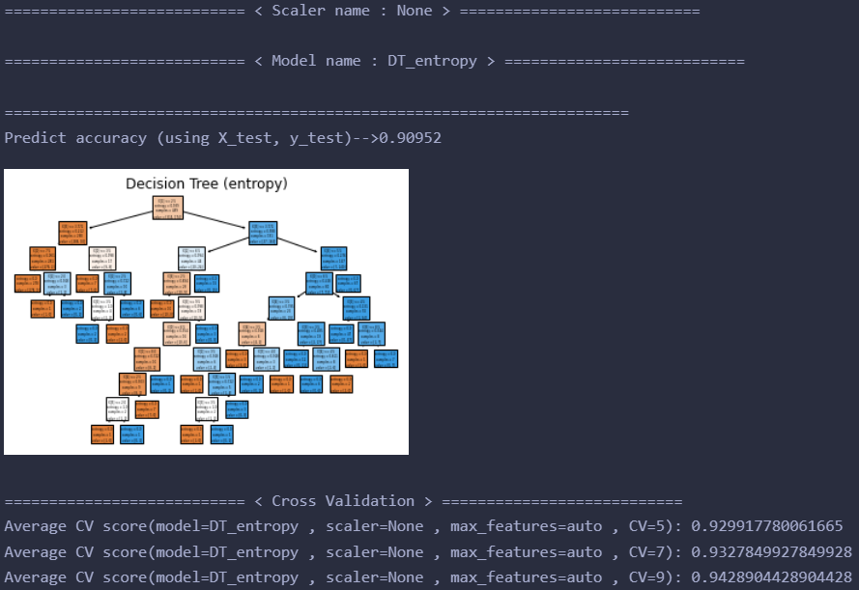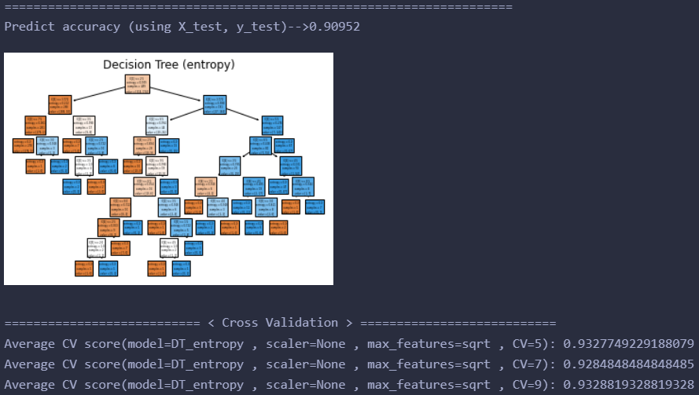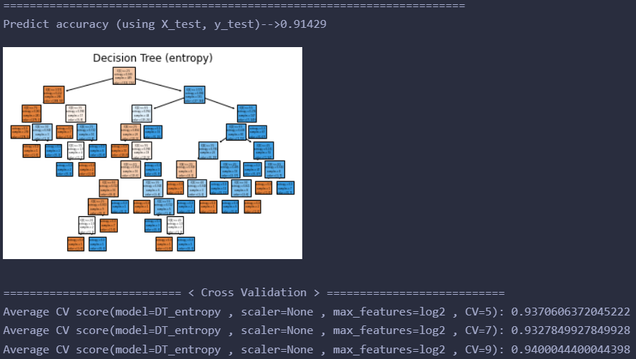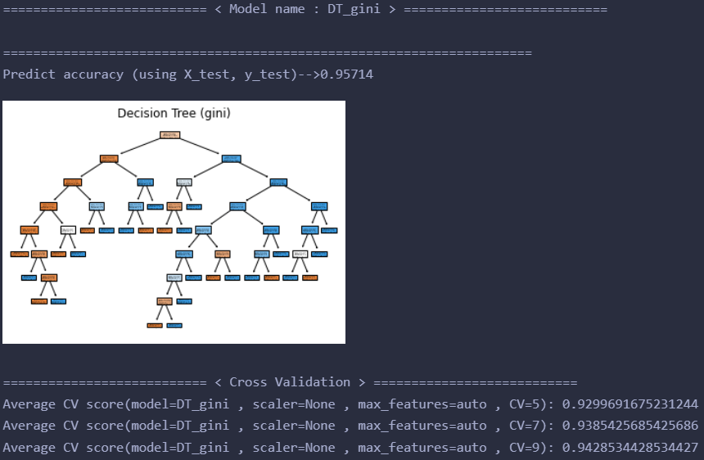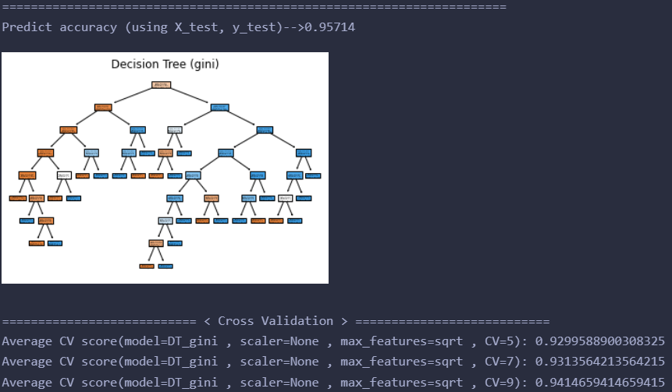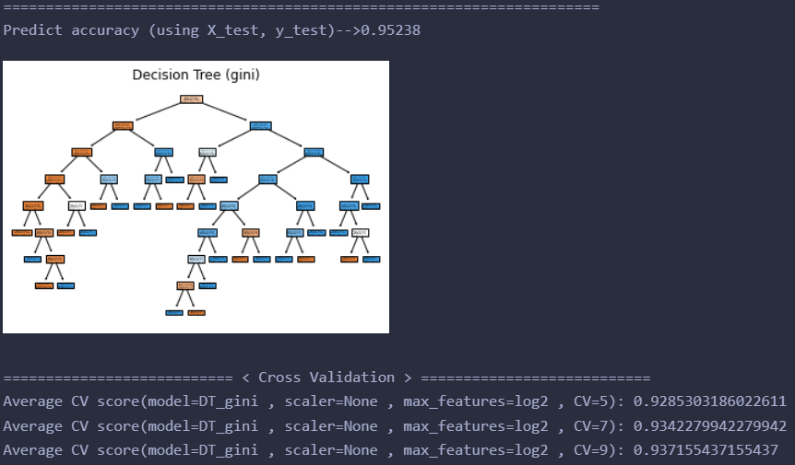

=========================== < Model name : SVM > ===========================

======================================================================

Predict accuracy (using X_test, y_test)-->0.97143

=========================== < Cross Validation > ===========================

Average CV score(model=SVM , scaler=None , kernel=linear , gamma=0.001 , C=0.01 , CV=5): 0.9642857142857142

Average CV score(model=SVM , scaler=None , kernel=linear , gamma=0.001 , C=0.01 , CV=7): 0.9657142857142856

Average CV score(model=SVM , scaler=None , kernel=linear , gamma=0.001 , C=0.01 , CV=9): 0.9643504643504642

======================================================================

Predict accuracy (using X_test, y_test)-->0.96667

=========================== < Cross Validation > ===========================

Average CV score(model=SVM , scaler=None , kernel=linear , gamma=0.001 , C=0.1 , CV=5): 0.9628468653648511

Average CV score(model=SVM , scaler=None , kernel=linear , gamma=0.001 , C=0.1 , CV=7): 0.9642712842712842

Average CV score(model=SVM , scaler=None , kernel=linear , gamma=0.001 , C=0.1 , CV=9): 0.9643134643134642

======================================================================

Predict accuracy (using X_test, y_test)-->0.96667

=========================== < Cross Validation > ===========================

Average CV score(model=SVM , scaler=None , kernel=linear , gamma=0.001 , C=1 , CV=5): 0.9628468653648511

Average CV score(model=SVM , scaler=None , kernel=linear , gamma=0.001 , C=1 , CV=7): 0.9642712842712842

Average CV score(model=SVM , scaler=None , kernel=linear , gamma=0.001 , C=1 , CV=9): 0.962888962888963

======================================================================

Predict accuracy (using X_test, y_test)-->0.97143

=========================== < Cross Validation > ===========================

Average CV score(model=SVM , scaler=None , kernel=linear , gamma=0.01 , C=0.01 , CV=5): 0.9642857142857142

Average CV score(model=SVM , scaler=None , kernel=linear , gamma=0.01 , C=0.01 , CV=7): 0.9657142857142856

Average CV score(model=SVM , scaler=None , kernel=linear , gamma=0.01 , C=0.01 , CV=9): 0.9643504643504642

======================================================================

Predict accuracy (using X_test, y_test)-->0.96667

=========================== < Cross Validation > ===========================

Average CV score(model=SVM , scaler=None , kernel=linear , gamma=0.01 , C=0.1 , CV=5): 0.9628468653648511

Average CV score(model=SVM , scaler=None , kernel=linear , gamma=0.01 , C=0.1 , CV=7): 0.9642712842712842

Average CV score(model=SVM , scaler=None , kernel=linear , gamma=0.01 , C=0.1 , CV=9): 0.9643134643134642

======================================================================

Predict accuracy (using X_test, y_test)-->0.96667

=========================== < Cross Validation > ===========================

Average CV score(model=SVM , scaler=None , kernel=linear , gamma=0.01 , C=1 , CV=5): 0.9628468653648511

Average CV score(model=SVM , scaler=None , kernel=linear , gamma=0.01 , C=1 , CV=7): 0.9642712842712842

Average CV score(model=SVM , scaler=None , kernel=linear , gamma=0.01 , C=1 , CV=9): 0.962888962888963

======================================================================

Predict accuracy (using X_test, y_test)-->0.97143

=========================== < Cross Validation > ===========================

Average CV score(model=SVM , scaler=None , kernel=linear , gamma=0.1 , C=0.01 , CV=5): 0.9642857142857142

Average CV score(model=SVM , scaler=None , kernel=linear , gamma=0.1 , C=0.01 , CV=7): 0.9657142857142856

Average CV score(model=SVM , scaler=None , kernel=linear , gamma=0.1 , C=0.01 , CV=9): 0.9643504643504642

======================================================================

Predict accuracy (using X_test, y_test)-->0.96667

=========================== < Cross Validation > ===========================

Average CV score(model=SVM , scaler=None , kernel=linear , gamma=0.1 , C=0.1 , CV=5): 0.9628468653648511

Average CV score(model=SVM , scaler=None , kernel=linear , gamma=0.1 , C=0.1 , CV=7): 0.9642712842712842

Average CV score(model=SVM , scaler=None , kernel=linear , gamma=0.1 , C=0.1 , CV=9): 0.9643134643134642

======================================================================

Predict accuracy (using X_test, y_test)-->0.96667

=========================== < Cross Validation > ===========================

Average CV score(model=SVM , scaler=None , kernel=linear , gamma=0.1 , C=1 , CV=5): 0.9628468653648511

Average CV score(model=SVM , scaler=None , kernel=linear , gamma=0.1 , C=1 , CV=7): 0.9642712842712842

Average CV score(model=SVM , scaler=None , kernel=linear , gamma=0.1 , C=1 , CV=9): 0.962888962888963

======================================================================

Predict accuracy (using X_test, y_test)-->0.97143

=========================== < Cross Validation > ===========================

Average CV score(model=SVM , scaler=None , kernel=linear , gamma=1 , C=0.01 , CV=5): 0.9642857142857142

Average CV score(model=SVM , scaler=None , kernel=linear , gamma=1 , C=0.01 , CV=7): 0.9657142857142856

Average CV score(model=SVM , scaler=None , kernel=linear , gamma=1 , C=0.01 , CV=9): 0.9643504643504642

======================================================================

Predict accuracy (using X_test, y_test)-->0.96667

=========================== < Cross Validation > ===========================

Average CV score(model=SVM , scaler=None , kernel=linear , gamma=1 , C=0.1 , CV=5): 0.9628468653648511

Average CV score(model=SVM , scaler=None , kernel=linear , gamma=1 , C=0.1 , CV=7): 0.9642712842712842

Average CV score(model=SVM , scaler=None , kernel=linear , gamma=1 , C=0.1 , CV=9): 0.9643134643134642

======================================================================

Predict accuracy (using X_test, y_test)-->0.96667

=========================== < Cross Validation > ===========================

Average CV score(model=SVM , scaler=None , kernel=linear , gamma=1 , C=1 , CV=5): 0.9628468653648511

Average CV score(model=SVM , scaler=None , kernel=linear , gamma=1 , C=1 , CV=7): 0.9642712842712842

Average CV score(model=SVM , scaler=None , kernel=linear , gamma=1 , C=1 , CV=9): 0.962888962888963

======================================================================

Predict accuracy (using X_test, y_test)-->0.97143

=========================== < Cross Validation > ===========================

Average CV score(model=SVM , scaler=None , kernel=linear , gamma=10 , C=0.01 , CV=5): 0.9642857142857142

Average CV score(model=SVM , scaler=None , kernel=linear , gamma=10 , C=0.01 , CV=7): 0.9657142857142856

Average CV score(model=SVM , scaler=None , kernel=linear , gamma=10 , C=0.01 , CV=9): 0.9643504643504642

======================================================================

Predict accuracy (using X_test, y_test)-->0.96667

=========================== < Cross Validation > ===========================

Average CV score(model=SVM , scaler=None , kernel=linear , gamma=10 , C=0.1 , CV=5): 0.9628468653648511

Average CV score(model=SVM , scaler=None , kernel=linear , gamma=10 , C=0.1 , CV=7): 0.9642712842712842

Average CV score(model=SVM , scaler=None , kernel=linear , gamma=10 , C=0.1 , CV=9): 0.9643134643134642

======================================================================

Predict accuracy (using X_test, y_test)-->0.96667

=========================== < Cross Validation > ===========================

Average CV score(model=SVM , scaler=None , kernel=linear , gamma=10 , C=1 , CV=5): 0.9628468653648511

Average CV score(model=SVM , scaler=None , kernel=linear , gamma=10 , C=1 , CV=7): 0.9642712842712842

Average CV score(model=SVM , scaler=None , kernel=linear , gamma=10 , C=1 , CV=9): 0.962888962888963

======================================================================

Predict accuracy (using X_test, y_test)-->0.68095

=========================== < Cross Validation > ===========================

Average CV score(model=SVM , scaler=None , kernel=poly , gamma=0.001 , C=0.01 , CV=5): 0.6553545734840698

Average CV score(model=SVM , scaler=None , kernel=poly , gamma=0.001 , C=0.01 , CV=7): 0.6554112554112554

Average CV score(model=SVM , scaler=None , kernel=poly , gamma=0.001 , C=0.01 , CV=9): 0.6557331557331557

======================================================================

Predict accuracy (using X_test, y_test)-->0.75714

=========================== < Cross Validation > ===========================

Average CV score(model=SVM , scaler=None , kernel=poly , gamma=0.001 , C=0.1 , CV=5): 0.7411819116135663

Average CV score(model=SVM , scaler=None , kernel=poly , gamma=0.001 , C=0.1 , CV=7): 0.7497979797979798

Average CV score(model=SVM , scaler=None , kernel=poly , gamma=0.001 , C=0.1 , CV=9): 0.752950752950753

======================================================================

Predict accuracy (using X_test, y_test)-->0.93810

=========================== < Cross Validation > ===========================

Average CV score(model=SVM , scaler=None , kernel=poly , gamma=0.001 , C=1 , CV=5): 0.9314080164439877

Average CV score(model=SVM , scaler=None , kernel=poly , gamma=0.001 , C=1 , CV=7): 0.9342712842712843

Average CV score(model=SVM , scaler=None , kernel=poly , gamma=0.001 , C=1 , CV=9): 0.9344174344174344

======================================================================

Predict accuracy (using X_test, y_test)-->0.96190

=========================== < Cross Validation > ===========================

Average CV score(model=SVM , scaler=None , kernel=poly , gamma=0.01 , C=0.01 , CV=5): 0.9514285714285716

Average CV score(model=SVM , scaler=None , kernel=poly , gamma=0.01 , C=0.01 , CV=7): 0.9528571428571428

Average CV score(model=SVM , scaler=None , kernel=poly , gamma=0.01 , C=0.01 , CV=9): 0.9529544529544529

======================================================================

Predict accuracy (using X_test, y_test)-->0.97143

=========================== < Cross Validation > ===========================

Average CV score(model=SVM , scaler=None , kernel=poly , gamma=0.01 , C=0.1 , CV=5): 0.9528571428571428

Average CV score(model=SVM , scaler=None , kernel=poly , gamma=0.01 , C=0.1 , CV=7): 0.9542857142857143

Average CV score(model=SVM , scaler=None , kernel=poly , gamma=0.01 , C=0.1 , CV=9): 0.9543789543789543

======================================================================

Predict accuracy (using X_test, y_test)-->0.96667

=========================== < Cross Validation > ===========================

Average CV score(model=SVM , scaler=None , kernel=poly , gamma=0.01 , C=1 , CV=5): 0.9499588900308324

Average CV score(model=SVM , scaler=None , kernel=poly , gamma=0.01 , C=1 , CV=7): 0.9556854256854257

Average CV score(model=SVM , scaler=None , kernel=poly , gamma=0.01 , C=1 , CV=9): 0.95006845006845

======================================================================

Predict accuracy (using X_test, y_test)-->0.94286

=========================== < Cross Validation > ===========================

Average CV score(model=SVM , scaler=None , kernel=poly , gamma=0.1 , C=0.01 , CV=5): 0.9399383350462488

Average CV score(model=SVM , scaler=None , kernel=poly , gamma=0.1 , C=0.01 , CV=7): 0.9370707070707072

Average CV score(model=SVM , scaler=None , kernel=poly , gamma=0.1 , C=0.01 , CV=9): 0.9385984385984385

======================================================================

Predict accuracy (using X_test, y_test)-->0.93333

=========================== < Cross Validation > ===========================

Average CV score(model=SVM , scaler=None , kernel=poly , gamma=0.1 , C=0.1 , CV=5): 0.9356526207605345

Average CV score(model=SVM , scaler=None , kernel=poly , gamma=0.1 , C=0.1 , CV=7): 0.9413708513708513

Average CV score(model=SVM , scaler=None , kernel=poly , gamma=0.1 , C=0.1 , CV=9): 0.9385984385984385

======================================================================

Predict accuracy (using X_test, y_test)-->0.92857

=========================== < Cross Validation > ===========================

Average CV score(model=SVM , scaler=None , kernel=poly , gamma=0.1 , C=1 , CV=5): 0.9371017471736897

Average CV score(model=SVM , scaler=None , kernel=poly , gamma=0.1 , C=1 , CV=7): 0.937085137085137

Average CV score(model=SVM , scaler=None , kernel=poly , gamma=0.1 , C=1 , CV=9): 0.9443519443519445

======================================================================

Predict accuracy (using X_test, y_test)-->0.93810

=========================== < Cross Validation > ===========================

Average CV score(model=SVM , scaler=None , kernel=poly , gamma=1 , C=0.01 , CV=5): 0.9256628982528262

Average CV score(model=SVM , scaler=None , kernel=poly , gamma=1 , C=0.01 , CV=7): 0.9256421356421356

Average CV score(model=SVM , scaler=None , kernel=poly , gamma=1 , C=0.01 , CV=9): 0.93005143005143

======================================================================

Predict accuracy (using X_test, y_test)-->0.93810

=========================== < Cross Validation > ===========================

Average CV score(model=SVM , scaler=None , kernel=poly , gamma=1 , C=0.1 , CV=5): 0.9256628982528262

Average CV score(model=SVM , scaler=None , kernel=poly , gamma=1 , C=0.1 , CV=7): 0.9256421356421356

Average CV score(model=SVM , scaler=None , kernel=poly , gamma=1 , C=0.1 , CV=9): 0.93005143005143

======================================================================

Predict accuracy (using X_test, y_test)-->0.93810

=========================== < Cross Validation > ===========================

Average CV score(model=SVM , scaler=None , kernel=poly , gamma=1 , C=1 , CV=5): 0.9256628982528262

Average CV score(model=SVM , scaler=None , kernel=poly , gamma=1 , C=1 , CV=7): 0.9256421356421356

Average CV score(model=SVM , scaler=None , kernel=poly , gamma=1 , C=1 , CV=9): 0.93005143005143

======================================================================

Predict accuracy (using X_test, y_test)-->0.93810

=========================== < Cross Validation > ===========================

Average CV score(model=SVM , scaler=None , kernel=poly , gamma=10 , C=0.01 , CV=5): 0.9256628982528262

Average CV score(model=SVM , scaler=None , kernel=poly , gamma=10 , C=0.01 , CV=7): 0.9256421356421356

Average CV score(model=SVM , scaler=None , kernel=poly , gamma=10 , C=0.01 , CV=9): 0.93005143005143

======================================================================

Predict accuracy (using X_test, y_test)-->0.93810

=========================== < Cross Validation > ===========================

Average CV score(model=SVM , scaler=None , kernel=poly , gamma=10 , C=0.1 , CV=5): 0.9256628982528262

Average CV score(model=SVM , scaler=None , kernel=poly , gamma=10 , C=0.1 , CV=7): 0.9256421356421356

Average CV score(model=SVM , scaler=None , kernel=poly , gamma=10 , C=0.1 , CV=9): 0.93005143005143

======================================================================

Predict accuracy (using X_test, y_test)-->0.93810

=========================== < Cross Validation > ===========================

Average CV score(model=SVM , scaler=None , kernel=poly , gamma=10 , C=1 , CV=5): 0.9256628982528262

Average CV score(model=SVM , scaler=None , kernel=poly , gamma=10 , C=1 , CV=7): 0.9256421356421356

Average CV score(model=SVM , scaler=None , kernel=poly , gamma=10 , C=1 , CV=9): 0.93005143005143

======================================================================

Predict accuracy (using X_test, y_test)-->0.68095

=========================== < Cross Validation > ===========================

Average CV score(model=SVM , scaler=None , kernel=rbf , gamma=0.001 , C=0.01 , CV=5): 0.6553545734840698

Average CV score(model=SVM , scaler=None , kernel=rbf , gamma=0.001 , C=0.01 , CV=7): 0.6554112554112554

Average CV score(model=SVM , scaler=None , kernel=rbf , gamma=0.001 , C=0.01 , CV=9): 0.6557331557331557

======================================================================

Predict accuracy (using X_test, y_test)-->0.95714

=========================== < Cross Validation > ===========================

Average CV score(model=SVM , scaler=None , kernel=rbf , gamma=0.001 , C=0.1 , CV=5): 0.9557142857142857

Average CV score(model=SVM , scaler=None , kernel=rbf , gamma=0.001 , C=0.1 , CV=7): 0.9585714285714285

Average CV score(model=SVM , scaler=None , kernel=rbf , gamma=0.001 , C=0.1 , CV=9): 0.9586709586709586

======================================================================

Predict accuracy (using X_test, y_test)-->0.96190

=========================== < Cross Validation > ===========================

Average CV score(model=SVM , scaler=None , kernel=rbf , gamma=0.001 , C=1 , CV=5): 0.9600000000000002

Average CV score(model=SVM , scaler=None , kernel=rbf , gamma=0.001 , C=1 , CV=7): 0.9628571428571429

Average CV score(model=SVM , scaler=None , kernel=rbf , gamma=0.001 , C=1 , CV=9): 0.9643689643689642

======================================================================

Predict accuracy (using X_test, y_test)-->0.96190

=========================== < Cross Validation > ===========================

Average CV score(model=SVM , scaler=None , kernel=rbf , gamma=0.01 , C=0.01 , CV=5): 0.9571325796505654

Average CV score(model=SVM , scaler=None , kernel=rbf , gamma=0.01 , C=0.01 , CV=7): 0.9614141414141414

Average CV score(model=SVM , scaler=None , kernel=rbf , gamma=0.01 , C=0.01 , CV=9): 0.9614829614829615

======================================================================

Predict accuracy (using X_test, y_test)-->0.96190

=========================== < Cross Validation > ===========================

Average CV score(model=SVM , scaler=None , kernel=rbf , gamma=0.01 , C=0.1 , CV=5): 0.9628468653648511

Average CV score(model=SVM , scaler=None , kernel=rbf , gamma=0.01 , C=0.1 , CV=7): 0.9628427128427128

Average CV score(model=SVM , scaler=None , kernel=rbf , gamma=0.01 , C=0.1 , CV=9): 0.962907462907463

======================================================================

Predict accuracy (using X_test, y_test)-->0.97143

=========================== < Cross Validation > ===========================

Average CV score(model=SVM , scaler=None , kernel=rbf , gamma=0.01 , C=1 , CV=5): 0.9585611510791366

Average CV score(model=SVM , scaler=None , kernel=rbf , gamma=0.01 , C=1 , CV=7): 0.9642712842712842

Average CV score(model=SVM , scaler=None , kernel=rbf , gamma=0.01 , C=1 , CV=9): 0.9643319643319644

======================================================================

Predict accuracy (using X_test, y_test)-->0.68095

=========================== < Cross Validation > ===========================

Average CV score(model=SVM , scaler=None , kernel=rbf , gamma=0.1 , C=0.01 , CV=5): 0.6553545734840698

Average CV score(model=SVM , scaler=None , kernel=rbf , gamma=0.1 , C=0.01 , CV=7): 0.6554112554112554

Average CV score(model=SVM , scaler=None , kernel=rbf , gamma=0.1 , C=0.01 , CV=9): 0.6557331557331557

======================================================================

Predict accuracy (using X_test, y_test)-->0.94286

=========================== < Cross Validation > ===========================

Average CV score(model=SVM , scaler=None , kernel=rbf , gamma=0.1 , C=0.1 , CV=5): 0.9413977389516959

Average CV score(model=SVM , scaler=None , kernel=rbf , gamma=0.1 , C=0.1 , CV=7): 0.9413997113997113

Average CV score(model=SVM , scaler=None , kernel=rbf , gamma=0.1 , C=0.1 , CV=9): 0.9414844414844415

======================================================================

Predict accuracy (using X_test, y_test)-->0.96190

=========================== < Cross Validation > ===========================

Average CV score(model=SVM , scaler=None , kernel=rbf , gamma=0.1 , C=1 , CV=5): 0.9528365878725591

Average CV score(model=SVM , scaler=None , kernel=rbf , gamma=0.1 , C=1 , CV=7): 0.9571139971139971

Average CV score(model=SVM , scaler=None , kernel=rbf , gamma=0.1 , C=1 , CV=9): 0.9614644614644615

======================================================================

Predict accuracy (using X_test, y_test)-->0.68095

=========================== < Cross Validation > ===========================

Average CV score(model=SVM , scaler=None , kernel=rbf , gamma=1 , C=0.01 , CV=5): 0.6553545734840698

Average CV score(model=SVM , scaler=None , kernel=rbf , gamma=1 , C=0.01 , CV=7): 0.6554112554112554

Average CV score(model=SVM , scaler=None , kernel=rbf , gamma=1 , C=0.01 , CV=9): 0.6557331557331557

======================================================================

Predict accuracy (using X_test, y_test)-->0.68095

=========================== < Cross Validation > ===========================

Average CV score(model=SVM , scaler=None , kernel=rbf , gamma=1 , C=0.1 , CV=5): 0.6553545734840698

Average CV score(model=SVM , scaler=None , kernel=rbf , gamma=1 , C=0.1 , CV=7): 0.6554112554112554

Average CV score(model=SVM , scaler=None , kernel=rbf , gamma=1 , C=0.1 , CV=9): 0.6557331557331557

======================================================================

Predict accuracy (using X_test, y_test)-->0.83810

=========================== < Cross Validation > ===========================

Average CV score(model=SVM , scaler=None , kernel=rbf , gamma=1 , C=1 , CV=5): 0.8770400822199385

Average CV score(model=SVM , scaler=None , kernel=rbf , gamma=1 , C=1 , CV=7): 0.8812987012987014

Average CV score(model=SVM , scaler=None , kernel=rbf , gamma=1 , C=1 , CV=9): 0.88002738002738

======================================================================

Predict accuracy (using X_test, y_test)-->0.68095

=========================== < Cross Validation > ===========================

Average CV score(model=SVM , scaler=None , kernel=rbf , gamma=10 , C=0.01 , CV=5): 0.6553545734840698

Average CV score(model=SVM , scaler=None , kernel=rbf , gamma=10 , C=0.01 , CV=7): 0.6554112554112554

Average CV score(model=SVM , scaler=None , kernel=rbf , gamma=10 , C=0.01 , CV=9): 0.6557331557331557

======================================================================

Predict accuracy (using X_test, y_test)-->0.68095

=========================== < Cross Validation > ===========================

Average CV score(model=SVM , scaler=None , kernel=rbf , gamma=10 , C=0.1 , CV=5): 0.6553545734840698

Average CV score(model=SVM , scaler=None , kernel=rbf , gamma=10 , C=0.1 , CV=7): 0.6554112554112554

Average CV score(model=SVM , scaler=None , kernel=rbf , gamma=10 , C=0.1 , CV=9): 0.6557331557331557

======================================================================

Predict accuracy (using X_test, y_test)-->0.68571

=========================== < Cross Validation > ===========================

Average CV score(model=SVM , scaler=None , kernel=rbf , gamma=10 , C=1 , CV=5): 0.6553545734840698

Average CV score(model=SVM , scaler=None , kernel=rbf , gamma=10 , C=1 , CV=7): 0.6652958152958153

Average CV score(model=SVM , scaler=None , kernel=rbf , gamma=10 , C=1 , CV=9): 0.6526991526991527

======================================================================

Predict accuracy (using X_test, y_test)-->0.68095

=========================== < Cross Validation > ===========================

Average CV score(model=SVM , scaler=None , kernel=sigmoid , gamma=0.001 , C=0.01 , CV=5): 0.6553545734840698

Average CV score(model=SVM , scaler=None , kernel=sigmoid , gamma=0.001 , C=0.01 , CV=7): 0.6554112554112554

Average CV score(model=SVM , scaler=None , kernel=sigmoid , gamma=0.001 , C=0.01 , CV=9): 0.6557331557331557

======================================================================

Predict accuracy (using X_test, y_test)-->0.95714

=========================== < Cross Validation > ===========================

Average CV score(model=SVM , scaler=None , kernel=sigmoid , gamma=0.001 , C=0.1 , CV=5): 0.95

Average CV score(model=SVM , scaler=None , kernel=sigmoid , gamma=0.001 , C=0.1 , CV=7): 0.9514285714285714

Average CV score(model=SVM , scaler=None , kernel=sigmoid , gamma=0.001 , C=0.1 , CV=9): 0.9529729529729529

======================================================================

Predict accuracy (using X_test, y_test)-->0.96190

=========================== < Cross Validation > ===========================

Average CV score(model=SVM , scaler=None , kernel=sigmoid , gamma=0.001 , C=1 , CV=5): 0.962857142857143

Average CV score(model=SVM , scaler=None , kernel=sigmoid , gamma=0.001 , C=1 , CV=7): 0.9614285714285714

Average CV score(model=SVM , scaler=None , kernel=sigmoid , gamma=0.001 , C=1 , CV=9): 0.9615199615199614

======================================================================

Predict accuracy (using X_test, y_test)-->0.68095

=========================== < Cross Validation > ===========================

Average CV score(model=SVM , scaler=None , kernel=sigmoid , gamma=0.01 , C=0.01 , CV=5): 0.6553545734840698

Average CV score(model=SVM , scaler=None , kernel=sigmoid , gamma=0.01 , C=0.01 , CV=7): 0.6554112554112554

Average CV score(model=SVM , scaler=None , kernel=sigmoid , gamma=0.01 , C=0.01 , CV=9): 0.6557331557331557

======================================================================

Predict accuracy (using X_test, y_test)-->0.60000

=========================== < Cross Validation > ===========================

Average CV score(model=SVM , scaler=None , kernel=sigmoid , gamma=0.01 , C=0.1 , CV=5): 0.5924460431654677

Average CV score(model=SVM , scaler=None , kernel=sigmoid , gamma=0.01 , C=0.1 , CV=7): 0.5882106782106782

Average CV score(model=SVM , scaler=None , kernel=sigmoid , gamma=0.01 , C=0.1 , CV=9): 0.5800125800125799

======================================================================

Predict accuracy (using X_test, y_test)-->0.34286

=========================== < Cross Validation > ===========================

Average CV score(model=SVM , scaler=None , kernel=sigmoid , gamma=0.01 , C=1 , CV=5): 0.36922918807810895

Average CV score(model=SVM , scaler=None , kernel=sigmoid , gamma=0.01 , C=1 , CV=7): 0.37500721500721496

Average CV score(model=SVM , scaler=None , kernel=sigmoid , gamma=0.01 , C=1 , CV=9): 0.39380989380989384

======================================================================

Predict accuracy (using X_test, y_test)-->0.68095

=========================== < Cross Validation > ===========================

Average CV score(model=SVM , scaler=None , kernel=sigmoid , gamma=0.1 , C=0.01 , CV=5): 0.6553545734840698

Average CV score(model=SVM , scaler=None , kernel=sigmoid , gamma=0.1 , C=0.01 , CV=7): 0.6554112554112554

Average CV score(model=SVM , scaler=None , kernel=sigmoid , gamma=0.1 , C=0.01 , CV=9): 0.6557331557331557

======================================================================

Predict accuracy (using X_test, y_test)-->0.57143

=========================== < Cross Validation > ===========================

Average CV score(model=SVM , scaler=None , kernel=sigmoid , gamma=0.1 , C=0.1 , CV=5): 0.5407810894141829

Average CV score(model=SVM , scaler=None , kernel=sigmoid , gamma=0.1 , C=0.1 , CV=7): 0.5264935064935065

Average CV score(model=SVM , scaler=None , kernel=sigmoid , gamma=0.1 , C=0.1 , CV=9): 0.521090021090021

======================================================================

Predict accuracy (using X_test, y_test)-->0.34286

=========================== < Cross Validation > ===========================

Average CV score(model=SVM , scaler=None , kernel=sigmoid , gamma=0.1 , C=1 , CV=5): 0.3318910585817061

Average CV score(model=SVM , scaler=None , kernel=sigmoid , gamma=0.1 , C=1 , CV=7): 0.3347041847041847

Average CV score(model=SVM , scaler=None , kernel=sigmoid , gamma=0.1 , C=1 , CV=9): 0.3276723276723277

======================================================================

Predict accuracy (using X_test, y_test)-->0.68095

=========================== < Cross Validation > ===========================

Average CV score(model=SVM , scaler=None , kernel=sigmoid , gamma=1 , C=0.01 , CV=5): 0.6553545734840698

Average CV score(model=SVM , scaler=None , kernel=sigmoid , gamma=1 , C=0.01 , CV=7): 0.6554112554112554

Average CV score(model=SVM , scaler=None , kernel=sigmoid , gamma=1 , C=0.01 , CV=9): 0.6557331557331557

======================================================================

Predict accuracy (using X_test, y_test)-->0.68095

=========================== < Cross Validation > ===========================

Average CV score(model=SVM , scaler=None , kernel=sigmoid , gamma=1 , C=0.1 , CV=5): 0.6553545734840698

Average CV score(model=SVM , scaler=None , kernel=sigmoid , gamma=1 , C=0.1 , CV=7): 0.6554112554112554

Average CV score(model=SVM , scaler=None , kernel=sigmoid , gamma=1 , C=0.1 , CV=9): 0.6557331557331557

======================================================================

Predict accuracy (using X_test, y_test)-->0.68095

=========================== < Cross Validation > ===========================

Average CV score(model=SVM , scaler=None , kernel=sigmoid , gamma=1 , C=1 , CV=5): 0.6553545734840698

Average CV score(model=SVM , scaler=None , kernel=sigmoid , gamma=1 , C=1 , CV=7): 0.6554112554112554

Average CV score(model=SVM , scaler=None , kernel=sigmoid , gamma=1 , C=1 , CV=9): 0.6557331557331557

======================================================================

Predict accuracy (using X_test, y_test)-->0.68095

=========================== < Cross Validation > ===========================

Average CV score(model=SVM , scaler=None , kernel=sigmoid , gamma=10 , C=0.01 , CV=5): 0.6553545734840698

Average CV score(model=SVM , scaler=None , kernel=sigmoid , gamma=10 , C=0.01 , CV=7): 0.6554112554112554

Average CV score(model=SVM , scaler=None , kernel=sigmoid , gamma=10 , C=0.01 , CV=9): 0.6557331557331557

======================================================================

Predict accuracy (using X_test, y_test)-->0.68095

=========================== < Cross Validation > ===========================

Average CV score(model=SVM , scaler=None , kernel=sigmoid , gamma=10 , C=0.1 , CV=5): 0.6553545734840698

Average CV score(model=SVM , scaler=None , kernel=sigmoid , gamma=10 , C=0.1 , CV=7): 0.6554112554112554

Average CV score(model=SVM , scaler=None , kernel=sigmoid , gamma=10 , C=0.1 , CV=9): 0.6557331557331557

======================================================================

Predict accuracy (using X_test, y_test)-->0.68095

=========================== < Cross Validation > ===========================

Average CV score(model=SVM , scaler=None , kernel=sigmoid , gamma=10 , C=1 , CV=5): 0.6553545734840698

Average CV score(model=SVM , scaler=None , kernel=sigmoid , gamma=10 , C=1 , CV=7): 0.6554112554112554

Average CV score(model=SVM , scaler=None , kernel=sigmoid , gamma=10 , C=1 , CV=9): 0.6557331557331557

====================== < Model name : logistic_regression > ======================

======================================================================

Predict accuracy (using X_test, y_test)-->0.96190

=========================== < Cross Validation > ===========================

Average CV score(model=logistic_regression , scaler=None , solver=newton-cg , CV=5): 0.962857142857143

Average CV score(model=logistic_regression , scaler=None , solver=newton-cg , CV=7): 0.9657142857142856

Average CV score(model=logistic_regression , scaler=None , solver=newton-cg , CV=9): 0.9643319643319642

======================================================================

Predict accuracy (using X_test, y_test)-->0.96190

=========================== < Cross Validation > ===========================

Average CV score(model=logistic_regression , scaler=None , solver=lbfgs , CV=5): 0.962857142857143

Average CV score(model=logistic_regression , scaler=None , solver=lbfgs , CV=7): 0.9657142857142856

Average CV score(model=logistic_regression , scaler=None , solver=lbfgs , CV=9): 0.9643319643319642

======================================================================

Predict accuracy (using X_test, y_test)-->0.96190

=========================== < Cross Validation > ===========================

Average CV score(model=logistic_regression , scaler=None , solver=liblinear , CV=5): 0.9614285714285714

Average CV score(model=logistic_regression , scaler=None , solver=liblinear , CV=7): 0.9614285714285715

Average CV score(model=logistic_regression , scaler=None , solver=liblinear , CV=9): 0.9615199615199614

======================================================================

Predict accuracy (using X_test, y_test)-->0.96190

=========================== < Cross Validation > ===========================

Average CV score(model=logistic_regression , scaler=None , solver=sag , CV=5): 0.962857142857143

Average CV score(model=logistic_regression , scaler=None , solver=sag , CV=7): 0.9628571428571429

Average CV score(model=logistic_regression , scaler=None , solver=sag , CV=9): 0.9615014615014614

======================================================================

Predict accuracy (using X_test, y_test)-->0.96190

=========================== < Cross Validation > ===========================

Average CV score(model=logistic_regression , scaler=None , solver=saga , CV=5): 0.962857142857143

Average CV score(model=logistic_regression , scaler=None , solver=saga , CV=7): 0.9614285714285715

Average CV score(model=logistic_regression , scaler=None , solver=saga , CV=9): 0.9615199615199614

**< Top_5 >**

**['model=SVM , scaler=standard , kernel=sigmoid , gamma=1 , C=0.1 , CV=9', 0.972878972878973]**

**['model=SVM , scaler=standard , kernel=sigmoid , gamma=1 , C=0.1 , CV=7', 0.9728427128427127]**

**['model=SVM , scaler=standard , kernel=sigmoid , gamma=1 , C=0.1 , CV=5', 0.9699897225077081]**

**['model=SVM , scaler=standard , kernel=sigmoid , gamma=10 , C=0.1 , CV=5', 0.9699897225077081]**

**['model=SVM , scaler=standard , kernel=sigmoid , gamma=1 , C=0.01 , CV=5', 0.9685611510791368]**